

**The Egyptian E-Learning University**

**Faculty of Computers and Information Technology**

**Student Assistant**

**GRADUATION PROJECT**

**PREPARED BY**

Anton Nashat Shokry ID: 20-01489

Batool Medhat Mohammed ID: 20-00647

Basant Yahia Mohamed ID: 20-00681

Beshoy Riad Youssef ID: 20-00657

Dina Ayman Mahmoud ID: 20-01827

Mariam Ashraf Sadek ID: 20-01880

Paula George Motawadea ID: 20-00403

**SUPERVISED BY**

**Dr. Mohamed Ashour** **Eng. Sara Gamal**

Associated Professor of Network Engineering Demonstrator, Department of

Information technology

**A Graduation Project Report Submitted for the Partial Fulfillment of the  
Requirements of the B.SC. Degree**

**Hurghada 2023-2024**

**Table of Contents**

1. Introduction 7
2. Functional Requirements 10
   1. Introduction 10
      1. Key Characteristics of Functional Requirements 10
   2. The Importance of Functional Requirements 11
   3. From Functional Requirements to User Experience 11
   4. Student Functional Requirements 12
      1. Registration 12
      2. Storing Files or URLs 12
      3. Summarization 13
      4. Quiz Generation 13
      5. Student Calendar View 14
      6. Conclusion 14
   5. Admin Functional Requirements 15
3. Non-Functional Requirements 17
   1. Definition 17
   2. System Qualities 17
4. Use Case Diagram 18
   1. Introduction 19
   2. Key Elements 19
   3. Diagram 20
   4. Actors 21
   5. Use Cases 23
5. Activity Diagram 24
   1. Introduction 24
   2. Student Activity Diagram 25
   3. Admin Activity Diagram 26
6. Class Diagram 28
   1. Student Sequence Diagram 30
      1. Introduction 31
      2. Key Elements 31
      3. Benefits of using sequence diagrams 31
7. Admin Sequence Diagram 32
8. Entity Relationship Diagram 35
   1. Introduction 35
   2. Diagram 35
   3. Overview 36
9. Database Schema 37
   1. Definition 38
   2. Components 38
   3. Diagram 39
10. Backend API 40
    1. What APIs Do in the Backend 40
    2. Gemini AI vs. Assembly AI: A Brief Overview 41
11. Design 44
    1. Landing Page 44
    2. Login Page 46
    3. Sign up Page 47
    4. Student_Side 48
       1. Dashboard 48
       2. Courses Page 50
       3. Course Details 51
       4. Quiz Page 53
       5. Quiz_Questions 55
       6. Student_Summary 59
       7. Student_GPA 62
       8. Student_Profile_Page 63
       9. Edit_Profile 64
       10. Contact us 65
       11. About us 66
    5. Admin_Side 67
       1. Admin_Dashboard 67
       2. Student_Informations 68
       3. Feedback 69
12. Implementation 71
    1. System's Programming Languages 71
    2. Frameworks 71
    3. API Logic 72
    4. Fetch Summarize API Response 76
    5. Fetch Quiz API response 77
    6. Fetches Quiz Questions 78
    7. API Interaction and Authentication 79
    8. Edit profile Logic 81
    9. Summary logic 84
    10. Calendar imp. 85
    11. Database Query Implementation 87
13. Reference URL 98
14. Conclusion 101

**INTRODUCTION**

**Chapter 1**

# Introduction

In the dynamic landscape of modern education, the imperative for innovative and efficient tools has intensified, especially with the surge in remote learning and online education.

Recognizing this evolving need, our graduation project endeavors to address these challenges by introducing a cutting-edge, web-based platform meticulously designed to revolutionize the student learning experience.

Our platform is not just another learning management system; it's a comprehensive ecosystem that goes beyond conventional boundaries. At its core, our project leverages the transformative power of Artificial Intelligence to enhance the studying life of students.

One of its standout features is the capability to receive diverse forms of content – be it video files, video links, or material documents – and harness AI to generate concise and insightful summaries, thereby providing students with key takeaways and aiding in information retention.

The innovation doesn't stop there. We understand that true comprehension goes hand-in-hand with assessment, and to cater to this, our platform incorporates a sophisticated quiz generation feature. This allows educators to effortlessly evaluate students' understanding of the material, fostering a more interactive and engaging learning environment.

By seamlessly integrating quizzes into the learning process, we aim to elevate the overall learning experience and provide valuable insights into each student's progress.

Furthermore, our platform offers students the convenience of uploading relevant materials, creating a personalized repository for future reference. This feature not only promotes organization but also empowers learners to build a comprehensive knowledge base that extends beyond the confines of traditional classrooms.

But the vision extends even further – our platform is designed to be adaptive and flexible. We understand the diverse needs of students and educators alike, and as such, our project encompasses a multitude of additional functionalities aimed at enhancing collaboration, fostering a sense of community, and providing a holistic learning experience.

In conclusion, our graduation project aspires to be a trailblazer in the realm of educational technology. By seamlessly merging the power of Artificial Intelligence with user-friendly features, we aim to redefine the educational landscape, making learning not just a task but an enriching and interactive journey. The future of education is here, and it's in the form of our comprehensive web-based platform – a catalyst for transformative learning experiences.

**Functional Requirement**

* Introduction
* The Importance of Functional Requirements
* From Functional Requirements to User Experience
* Student Functional Requirements
* Admin Functional Requirements

**Chapter 2**

# Functional Requirements

## Introduction

A functional requirement defines what a system or application must do, without specifying how it should do it. In simpler terms, it is like a to-do list that outlines the tasks a system needs to perform but does not dictate the specific steps involved in completing them.

This allows developers to have flexibility in designing the system if they achieve the desired functionality.

### Key Characteristics of Functional Requirements

* Focus on what: They describe the system's behavior and the features it must provide.
* Independent of how: They don't specify the implementation details, or the technology used to build the system.
* Clear and concise: They should be easy to understand for both technical and non-technical stakeholders.
* Measurable: They should be defined in a way that allows their achievement to be verified.

## 

## The Importance of Functional Requirements

* Clarity and communication: They provide a clear understanding of what the system needs to do, which helps to avoid misunderstandings and ensure that everyone is on the same page.
* Planning and estimation: They form the basis for planning and estimating the effort required to develop the system.
* Testing and validation: They are used to test and validate the system to ensure that it meets the intended requirements.

## From Functional Requirements to User Experience

Understanding what a system needs to do is crucial, but it is only half the story. To create a truly exceptional user experience, we need to delve deeper into the specifics of how it should function.

This is where functional requirements come into play. They act as the bridge between abstract concepts and concrete features, paving the way for a system that's not just functional, but also intuitive, engaging, and effective.

## Student Functional Requirements

### Registration

Students can sign up and log in smoothly using various methods, manage their accounts, and reset passwords - all for a frictionless learning journey.

* + Student can sign up for an account using their email, Google, Facebook, or other relevant authentication methods.
  + Student can log in using the same authentication method.
  + Student can edit account.
  + Student can reset password.

### Storing Files or URLs

Students can keep all their learning materials organized in one place:

* Store course files: Upload documents like PDFs, DOCX, and PPTs for easy access and reference.
* Bookmark online videos: Save URLs from various platforms like YouTube, making video-based learning convenient.

This feature eliminates the hassle of searching for scattered materials, enabling students to focus on what matters most - learning and understanding.

### Summarization

Learn Smarter, Not Harder.

Automatic summarization on demand, Students can access summaries in three ways:

1. Link and Learn: Paste video URLs from popular platforms like YouTube, Facebook and many more and instantly get key points.
2. Upload and Summarize: Upload their own learning videos for personalized summaries.
3. Text in a Flash: Get summaries of uploaded documents (PDF, DOCX, PPT) for efficient knowledge grasp.

This feature empowers students to focus on understanding, not just consuming information, leading to effective learning and improved knowledge retention.

### Quiz Generation

Students can take active control of their learning by:

* Crafting personalized quizzes: Generate quizzes based on summarized materials, reinforcing knowledge and understanding.
* Tracking progress: View quiz scores to identify strengths and areas for improvement.
* Diverse questions, diverse insights: Create multiple quizzes from the same material, ensuring comprehensive self-assessment and deeper learning.

This empowers students to become active participants in their learning journey, fostering engagement and knowledge retention.

### Student Calendar View

Stay Organized, Stay Ahead.

Students get a personal calendar to manage their learning journey:

* Access and edit: View and update their calendar to keep upcoming lectures, quizzes, and deadlines organized.
* Clear visibility: Easily see important dates and events in one central location.
* Proactive planning: Stay ahead of schedule and avoid last-minute surprises.

This calendar empowers students to manage their time effectively and achieve academic success.

### Conclusion

Students can register and manage their learning journey seamlessly, storing files, URLs, and accessing summaries from various materials (text, videos, documents) to gain understanding, test their knowledge with personalized quizzes, and track their progress through a central calendar, all designed for focused learning and improved knowledge retention.

## Admin Functional Requirements

1. Admin Dashboard Access:

* Secure login gateway for admins to access the platform overseeing student data and system functions.

2. Student Profile Visibility:

* View detailed information on individual students, including their registration details and their contact details.

3. Student Account Management:

* Manage student accounts with capabilities to deactivate and edit the accounts ensuring system integrity.

5. Feedback Review and Analysis:

* View and analyze student feedback submitted through the platform, gaining valuable insights into their experience.

6. Responsive Communication:

* Directly respond to student feedback, addressing concerns, providing guidance, and fostering an open communication channel.

7. Student Performance Visibility:

* Access and analyze student statistics, including active students with their quiz scores, chart for registered students, and overall engagement, for informed decision-making.

These admin functionalities create a comprehensive management system, empowering admins to support students effectively, optimize learning experiences, and ensure the platform's smooth operation.

**Non-Functional Requierments**

* Definition
* System Qualities

**Chapter 3**

# Non-Functional Requirements

## Definition

Non-functional requirements (NFRs) are specifications that describe how a system should behave rather than what it should do. They focus on the qualities of the system.

## System Qualities

1-Usability: Ease of use and understandability of the system for the end-users.

2-Reliability: System’s ability to function correctly and consistently under normal and abnormal conditions.

3-Scalability: As needs grow, can the system handle it? For future updates.

4-Performance: Improve the speed, scalability, and responsiveness of the system.

5-Security: Scan uploaded files or URLs from any malicious viruses or a dangerous script using a powerful Scanning API.

6-Maintainability: Ease of maintaining the system. (testing, debugging, and modifying the system).

NFRs are essential for ensuring that a system meets the needs of its users and stakeholders. They are often just as important as functional requirements, which define what the system should do.

**Chapter 4**

# Use Case Diagram

* Introduction
* Key Elements
* Diagram
* Actors
* Use Cases

## Introduction

A Use Case Diagram is a type of diagrams used to represent interactions between a system and various users or other systems. It illustrates the functions or services provided by the system to users and how users interact with the system.

## Key Elements

There are several key elements:

1. Actors: These represent the different types of users or external systems that interact with the system being modeled. Actors can be individuals, organizations, or even other systems.
2. Use Cases: These represent the various actions or services that the system provides to its actors. Each use case describes a specific functionality or task that the system can perform.
3. Relationships: There are different types of relationships in a Use Case Diagram (Association, Extend, Include and Generalization)

## A diagram of a student Description automatically generatedDiagram

[Diagram link](https://lucid.app/lucidspark/2ffcc11f-9f51-4931-ba74-218cc78546fd/edit?viewport_loc=-1315%2C-420%2C6220%2C2994%2C0_0&invitationId=inv_e0170425-e689-48ff-94ea-f39af460e630)

## Actors

This system offers various functionalities to students and administrators. Let's break it down:

The use case diagram explains a Students Assistance System. We have 3 actors such as:

1. Students.
2. Administrator.
3. AI.
4. **Student:** This is the primary user of the system and can perform actions like:

* Login: Student can login to the website or reset password when he forgets password.
* Sign up: Student can sign up when he does not have an account.
* Upload: Student can upload Video, lecture material or URLs to confirm it into summary text.
* Feedback: Students can send feedback on the system's usability and features to admins.
* Store: Student can store lecture material or URLs in website.
* Attempt: Students can submit completed assignments through the system and can access their grades for different courses.
* Delete: Student can delete account
* Edit: Student can edit like (change name, update profile image or change email).
* Calendar: Viewing calendar and edit.

1. **Administrator:** This admin in student in this system and has the following capabilities:

* Show student profile: The Admin can access the students’ pages and know their information, such as their name, email, etc.
* Show student statistics: The Admin can display student statistics in terms of who is currently active, who obtained the highest score in quizzes, etc.
* View feedback: The admin can see comments from students and respond to them.

1. **AI**: can play a significant role in the student assistance system such as:

* Summarize: AI takes a video, lecture material, or URLs from student and converts it into summarize text.
* Generate quiz: The AI takes the lecture material from the student or takes the summary text and creates a quiz on it consisting of true and false or MCQ.
* Check grade: AI corrects the answers, displays them to the student, and records this score.

## Use Cases

* Sign Up
* Login
* Edit Account
* Update Profile Image
* Change Name
* Change Email
* Show Student Profile
* Show Student Statistics
* Attempt Quizzes
* View Feedback
* Respond to Feedback
* Show Calendar
* Edit/Add Calendar Item
* Delete Account
* Verify Password
* Reset Password
* Account Validation
* Display Login Error
* Store Material (File)
* Store Material (URL)
* Generate Quiz
* Check Grade
* Summarize
* Add Feedback
* Upload URL
* Upload Video
* Upload lecture Material

**Chapter 5**

# Activity Diagram

**Activity Diagram**

* Introduction
* Student Activity Diagram
* Admin Activity Diagram

## Introduction

An activity diagram is a type of UML diagram used to visualize the flow of actions within a system.

In an activity diagram, activities are represented as nodes, and the flow of control between activities is represented by arrows. Activities can represent various types of actions, such as tasks performed by users, processes within the system, or decisions made based on certain conditions.

Key components of an activity diagram include:

**Initial Node:** Represents the starting point of the activity diagram.

**Activity Nodes:** Represent specific actions or tasks to be performed within the system. .

**Decision Nodes:** Represent points where the flow of control branches based on certain conditions.

**Merge Nodes:** Represent points where multiple branches of control converge back into a single flow.

**Fork Nodes:** Represent points where the flow of control splits into multiple parallel flows.

**Join Nodes:** Represent points where parallel flows converge back into a single flow.

**Final Node:** Represents the ending point of the activity diagram.

## Student Activity Diagram

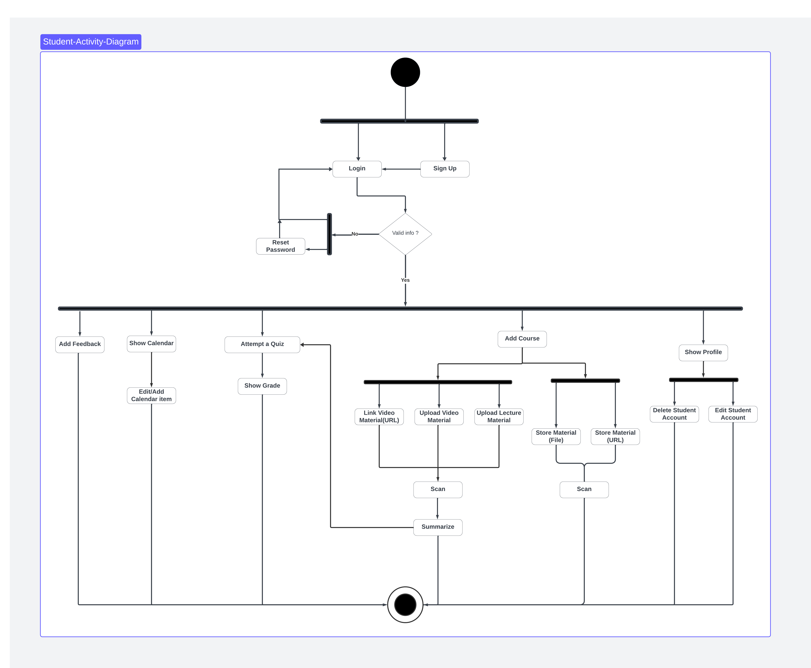

[Diagram Link](https://lucid.app/lucidspark/be7c0bd2-d77b-412d-bea0-c616986a9f8e/edit?viewport_loc=-1571%2C235%2C6260%2C3014%2C0_0&invitationId=inv_9470bd2c-de24-4ca8-ab77-608bede87c45)

## Admin Activity Diagram

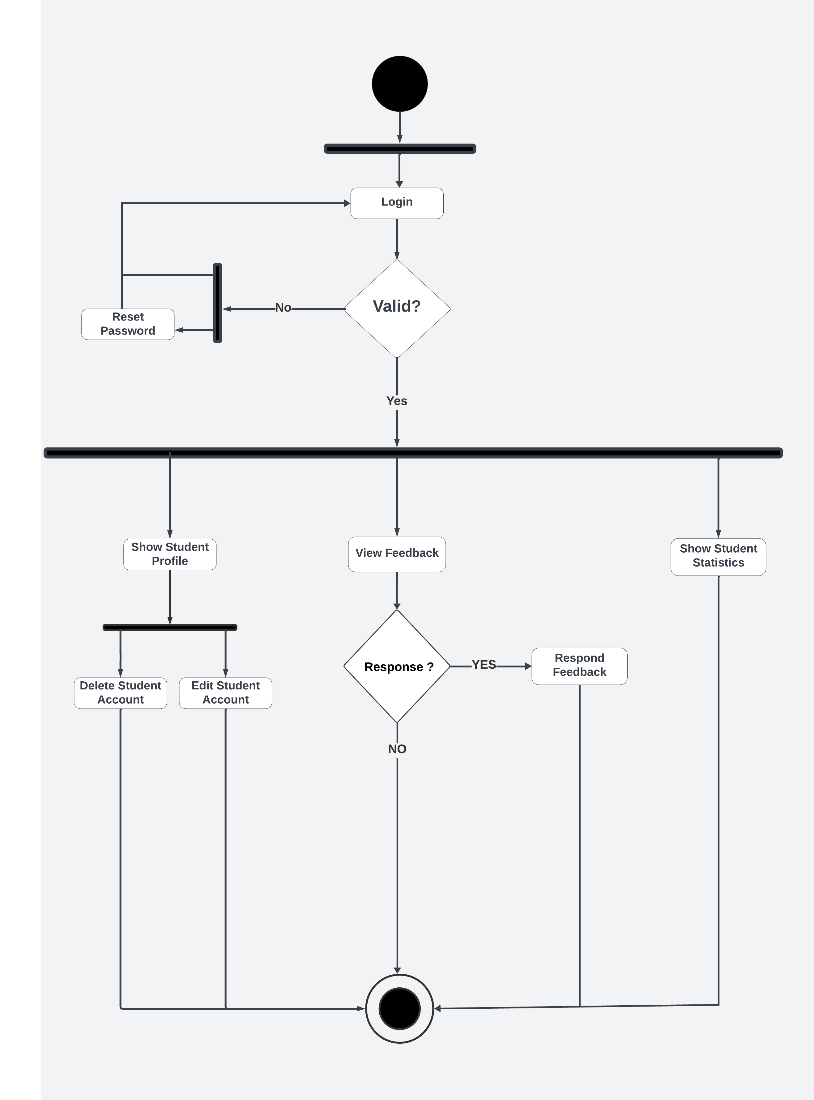

[Diagram Link](https://lucid.app/lucidspark/014326d2-87e9-430b-b440-543830cc0686/edit?viewport_loc=-2917%2C427%2C8524%2C4103%2C0_0&invitationId=inv_b1ba015b-4904-4ce4-8da1-a30327ee48b6)

**Class Diagram**

**Chapter 6**

# Class Diagram

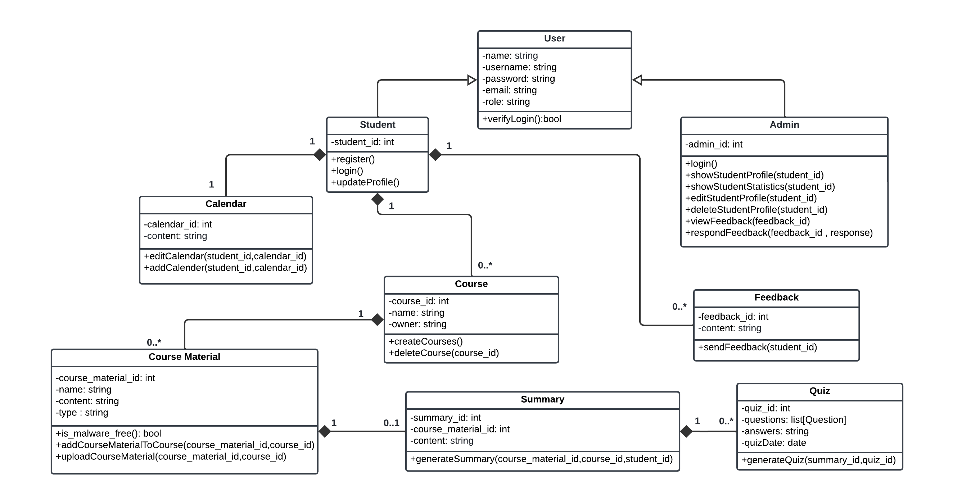

[Diagram Link](https://lucid.app/lucidchart/1a14f01d-eb8e-4c5a-a3de-56ab49144f85/edit?viewport_loc=-588%2C-1282%2C3816%2C1710%2CHWEp-vi-RSFO&invitationId=inv_75a64944-536e-40db-9160-69d75b14a28e)

**Chapter 7**

**Sequence Diagram**

* Student Sequence Diagram
* Admin Sequence Diagram

## Student Sequence Diagram

### Introduction

A sequence diagram, also known as a system sequence diagram (SSD), is a type of UML (Unified Modeling Language) diagram that visually depicts the interactions between objects in a system over time. They are primarily used in software development and system design to document and understand how different parts of a system communicate and collaborate to achieve specific goals.

### Key Elements

* Lifelines: Vertical lines representing objects participating in the interaction. Each lifeline represents the existence of an object over time.
* Messages: Horizontal arrows drawn between lifelines, indicating the messages or signals exchanged between objects. The arrows denote the flow of information and the order of interactions.
* Activation bars: Narrow rectangles placed on lifelines, showing the period during which an object is actively involved in processing a message.
* Control flow: Branching and looping structures to represent alternative execution paths or repeated actions.

### Benefits of using sequence diagrams

* Clearly visualize interaction flow: Sequence diagrams offer a clear understanding of how objects interact and the sequence of events involved in a specific use case.
* Identify potential issues: Analyzing the interactions can help identify potential design flaws, concurrency problems, or performance bottlenecks.
* Improve communication and collaboration: Sequence diagrams can be used to communicate system design to developers, testers, and other stakeholders.
* Document system behavior: They serve as valuable documentation for future reference and maintenance.

# Admin Sequence Diagram

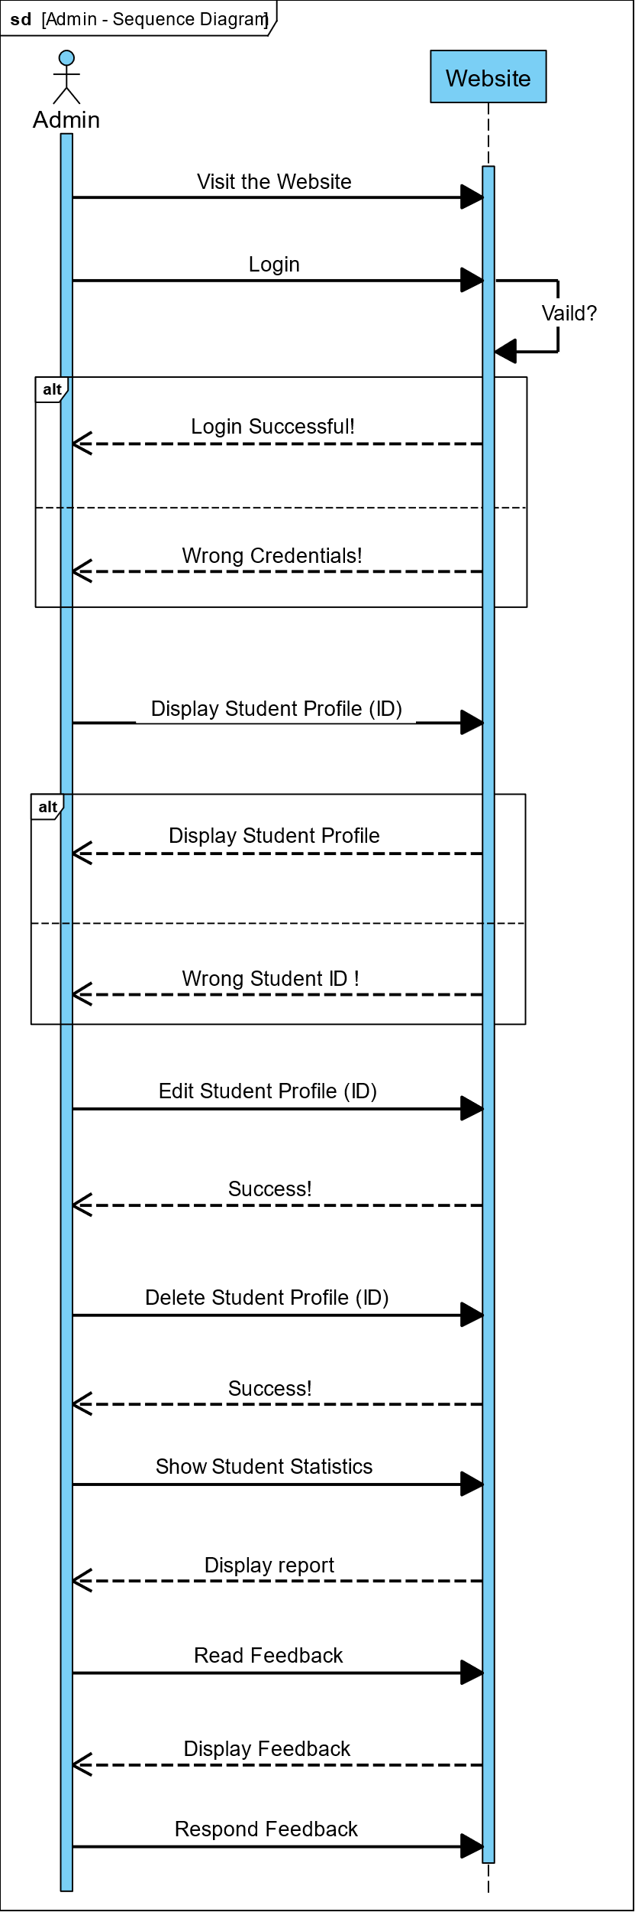A sequence diagram is a type of UML diagram used to visualize the interactions between objects within a system over time. It represents the sequence of messages exchanged among these objects to accomplish a specific task.

1. **Objects:** Represented as vertical lines (lifelines). These objects can be subsystems or actors interacting with the system.
2. **Messages:** Represented as horizontal solid arrows between lifelines, indicates the interaction between objects. Messages can be synchronous, asynchronous.
3. **Return Messages:** Indicate the response or return value sent by the recipient object back to the sender object after processing a message.

Sequence diagrams are particularly useful for:

* Describing the dynamic behavior of a system by showing how objects collaborate with each other.
* Identifying the sequence of interactions required to accomplish a scenario.
* Analyzing the timing and order of messages exchanged between objects.

**Chapter 8**

**Entity Relationship Diagram**

* Introduction
* Diagram
* Overview

# Entity Relationship Diagram

## Introduction

An Entity-Relationship Diagram (ERD) is a type of data modeling technique used to visually represent the structure of a database and the relationships between different. It's commonly used in conceptual modeling to illustrate the structure of data and how entities relate to each other.

## Diagram

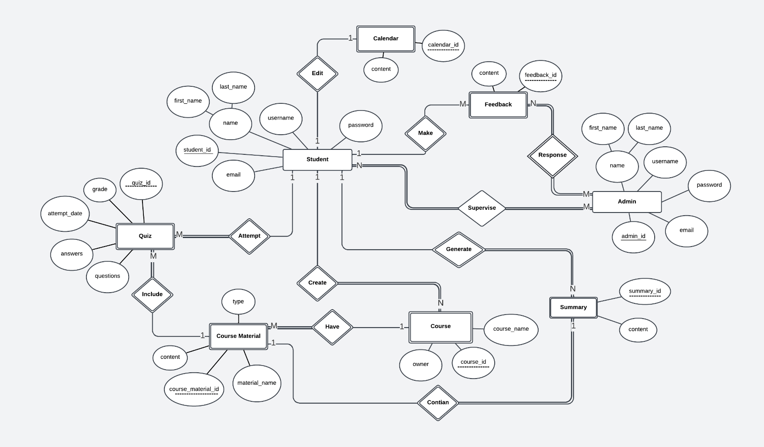

[Diagram Link](https://lucid.app/lucidspark/a27d2c92-8a6e-45af-9a1c-64481f600f2e/edit?viewport_loc=-2310%2C305%2C2948%2C1425%2C0_0&invitationId=inv_aeec8473-26cf-49a9-a6fc-66f5222089bd)

## Overview

* Entity: represents a real-world object or concept that can be uniquely identified. Entities are usually nouns.
* Attributes: Attributes describe the characteristics of an entity.
* Relationships: Relationships describe how entities are related to each other. they are typically labeled with verbs to describe the nature of the relationship.
* Cardinality: Cardinality defines the numerical relationship between two entities in a relationship. Common cardinality notations include "one-to-one," "one-to-many," and "many-to-many."

# **Database Schema**

**Database Schema**

* **Schema Database Diagram**
* **Definition**
* **Components**
* **Diagram**

**Chapter 9**

## Definition

* + A database schema represents the logical view of an entire database, outlining its structure and organization.

## Components

* + **Tables**: Fundamental units containing related data entities.
  + **Columns/Fields**: Define attributes of data entities.
  + **Data Types**: Specify the kind of data columns can hold.
  + **Constraints**: Enforce rules for data integrity (e.g., primary keys, foreign keys).
  + **Relationships**: Define connections between tables (e.g., one-to-many, many-to-many).
  + **Indexes**: Structures improving data retrieval speed.

## Diagram

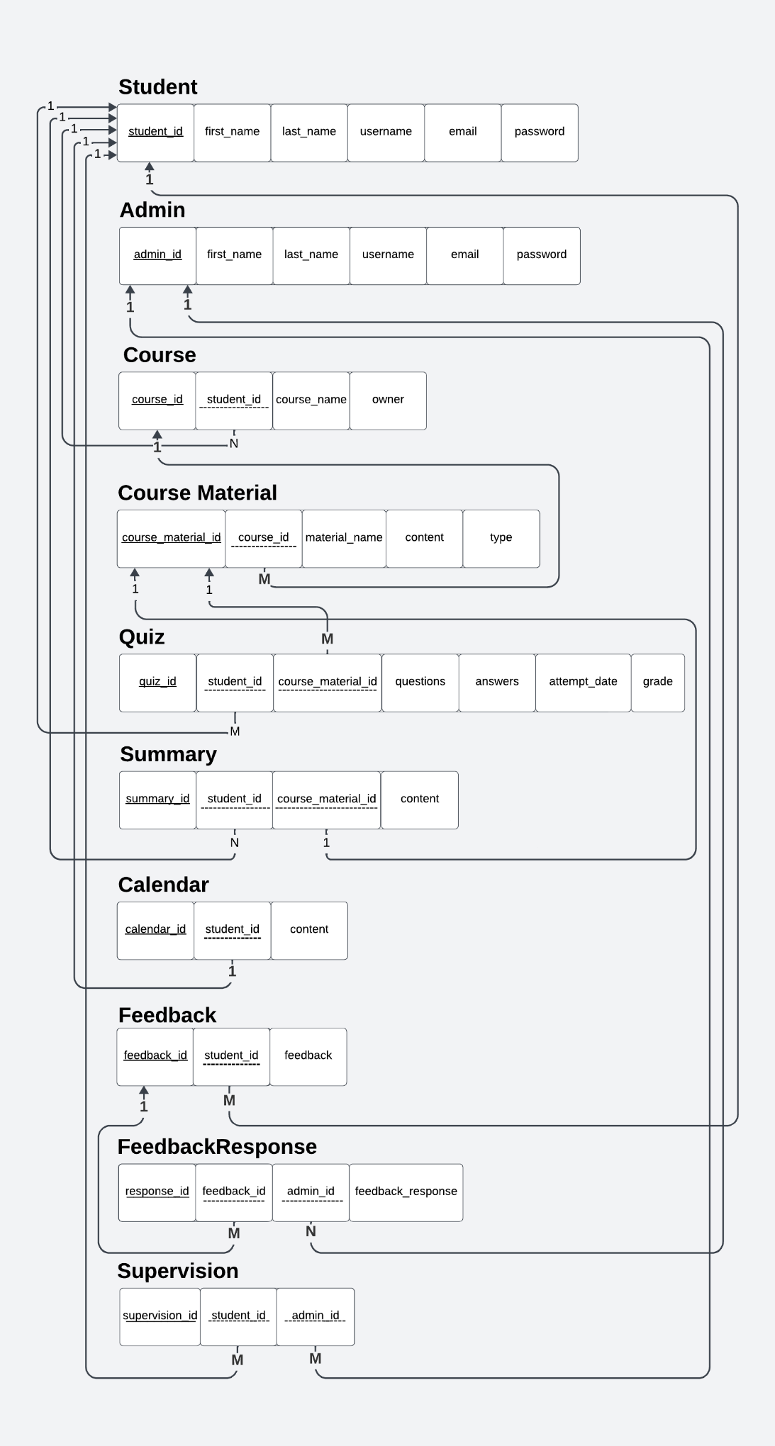

# Backend API

API (Application Programming Interface) refers to a defined set of rules and functionalities that allows different software systems to communicate and interact with each other. It acts as a translator, enabling communication between the user interface (front-end) and the backend components of an application.

Think of an API as a waiter in a restaurant:

* You (the user) provide a request (order) through the menu (API documentation).
* The waiter (API) takes your request to the kitchen (backend).
* The kitchen prepares your order and sends it back through the waiter.
* You receive your prepared food (response) and enjoy it.

## What APIs Do in the Backend

Here's a breakdown of what APIs does in the backend:

* The API exposes specific backend functions like data retrieval, manipulation, or processing to external applications or front-end components.
* APIs shield the inner workings of the backend from external systems, hiding implementation details and security concerns
* Restrict access to sensitive data to ensures only authorized systems can interact with the backend and helps prevent unauthorized access.

APIs play a crucial role in backend development by enabling secure, controlled, and standardized communication between various software systems.

Our API, version 0.6.1, functions as a powerful tool for both video summarization and quiz generation. It can process any local video format or retrieve online videos for extracting key points to condense them into summaries. Furthermore, it leverages these summaries to create engaging quiz questions, fostering deeper understanding and knowledge retention.

The API utilizes the advanced NLP capabilities of Gemini AI and the robust speech recognition features of Assembly AI.

## Gemini AI vs. Assembly AI: A Brief Overview

Gemini AI Model:

* Focus: Powerful natural language processing (NLP) capabilities.
* Strengths: Generates text content, translates languages, writes different creative formats, and answers your questions in an informative way.
* Applications: Chatbots, content creation, web applications, and more.
* Key characteristics: Versatile, efficient, and constantly evolving.

Assembly AI Model:

* Focus: Robust speech recognition technology.
* Strengths: Transforms spoken words into accurate text with low latency, supports various languages and accents, and offers advanced features like speaker diarization.
* Applications: Video and audio transcription, meeting minutes generation, dictation tools, and more.
* 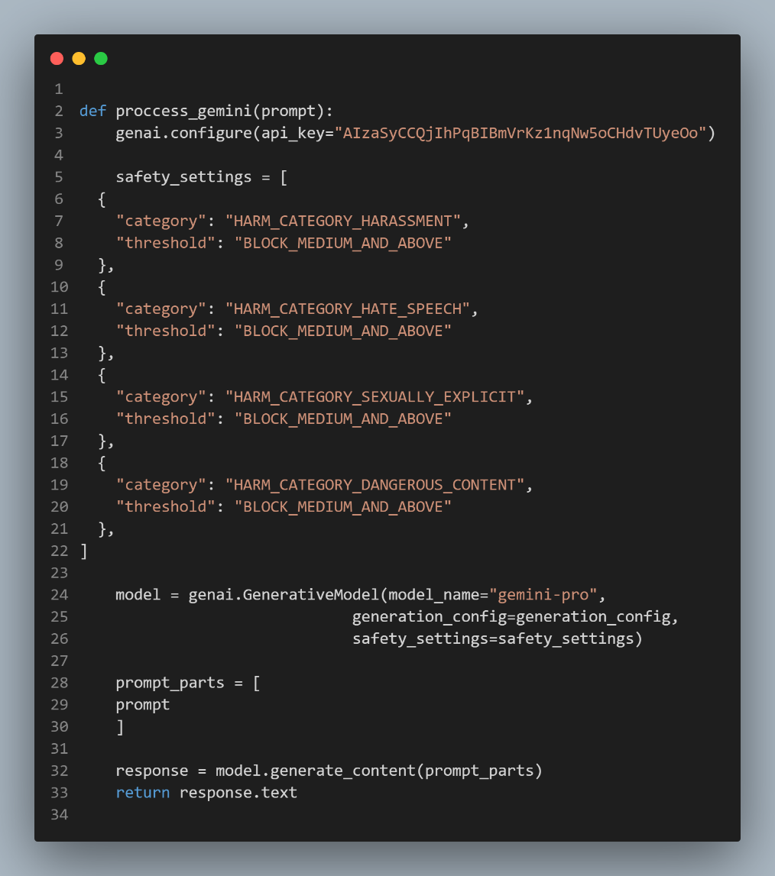Key characteristics: High accuracy, real-time capabilities, and diverse functionalities.

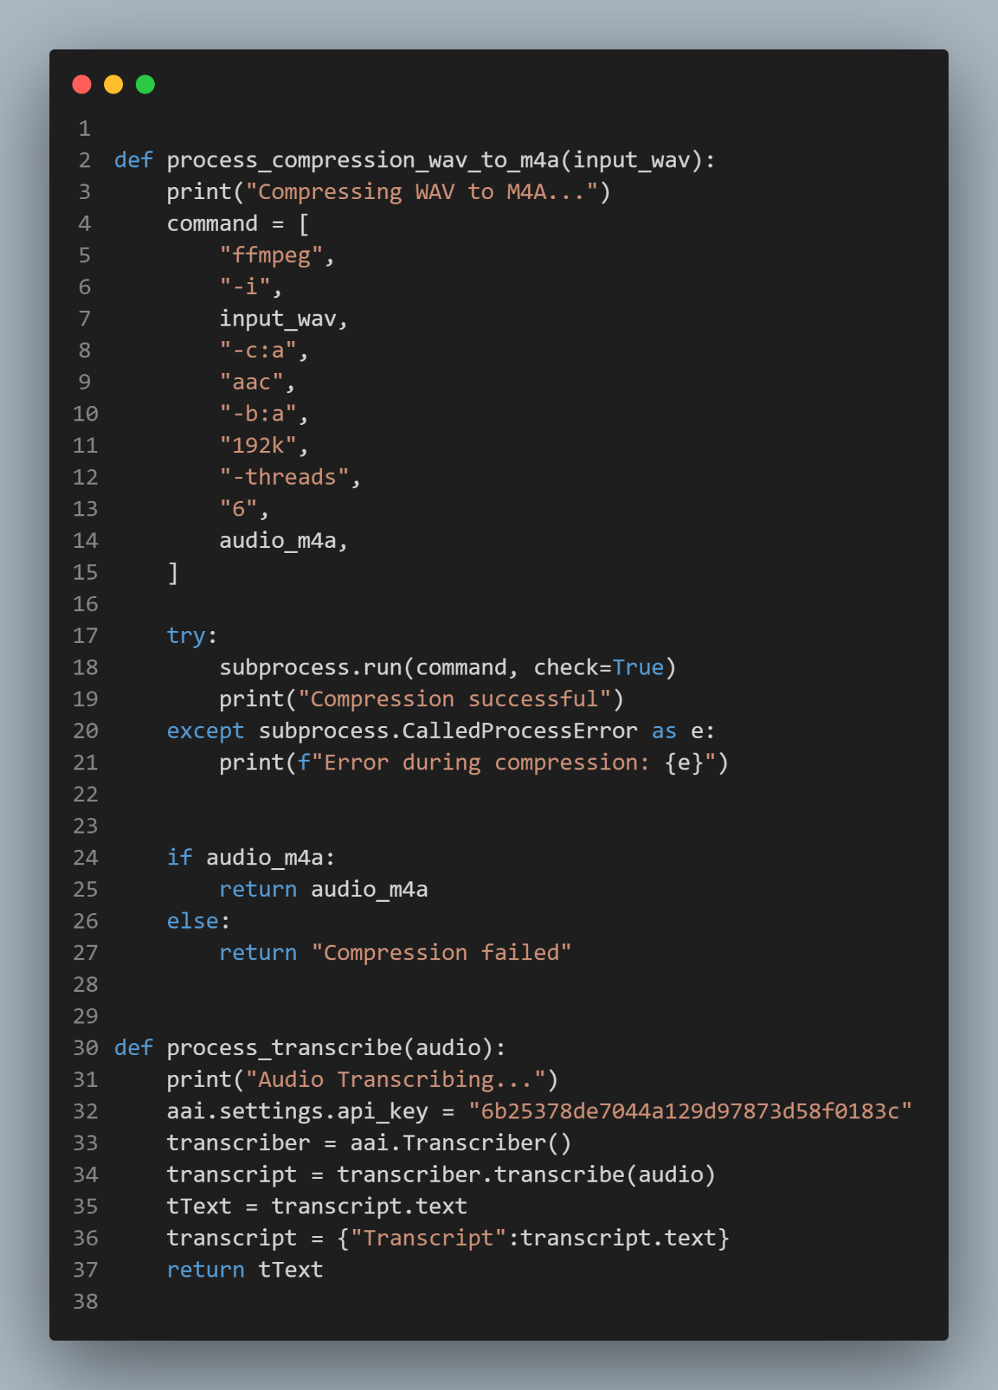

**Design**

* **Landing**
* **Login & Registration**
* **Student Side**
* **Admin Side**

**Chapter 10**

# Design

## Landing Page

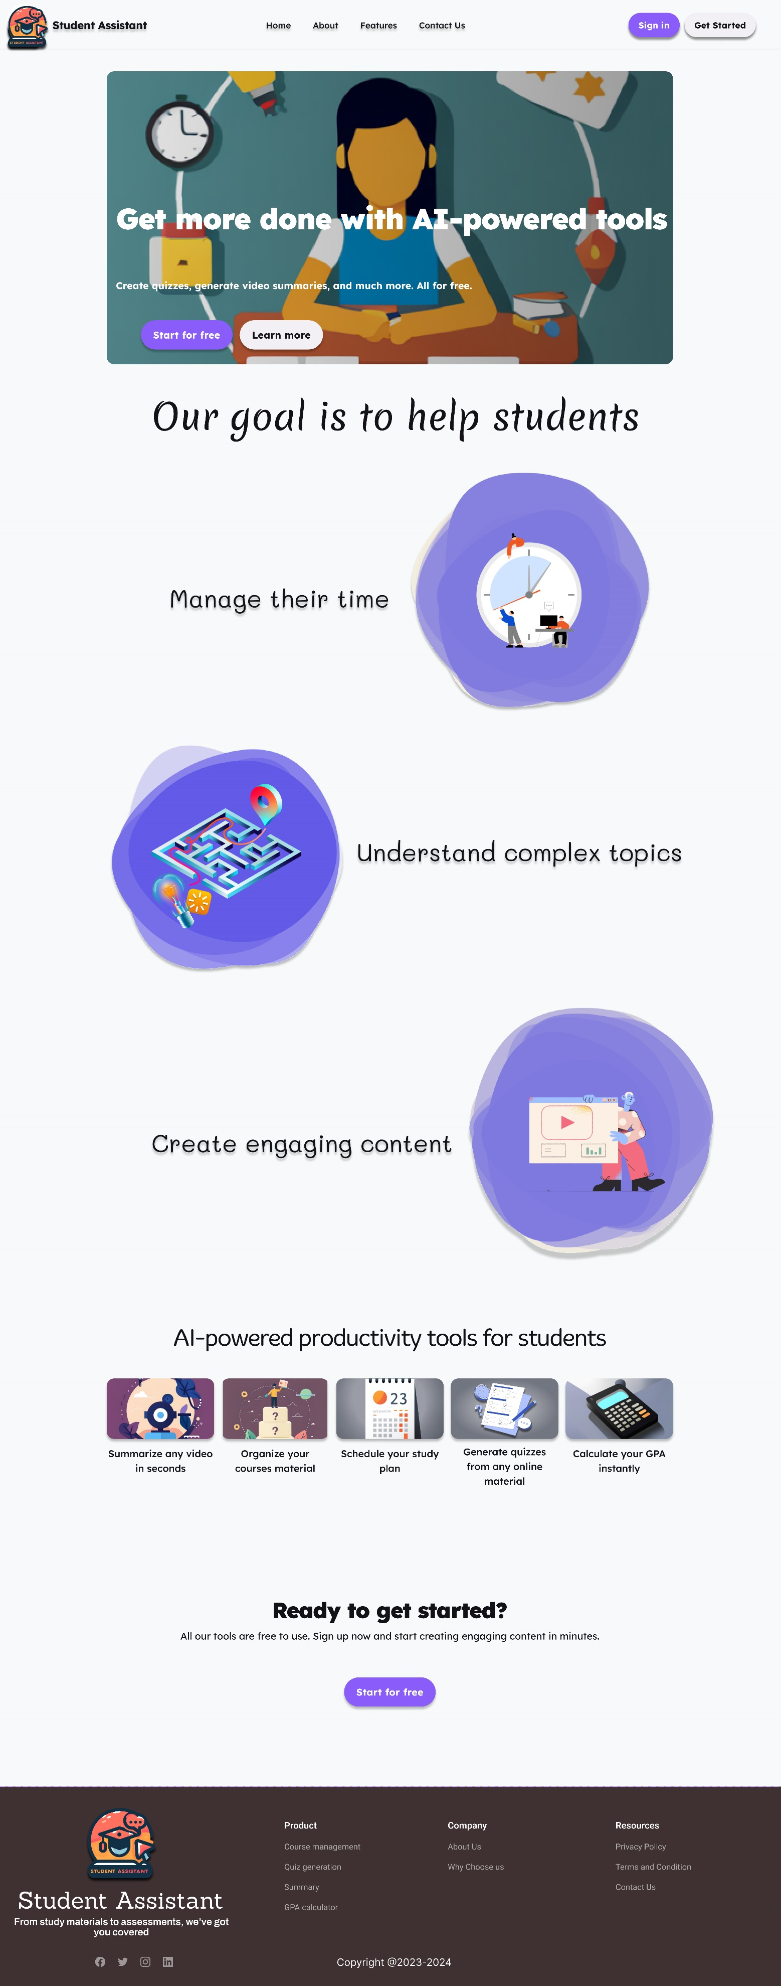

## Login Page

## Sign up Page

## Student_Side

### Dashboard

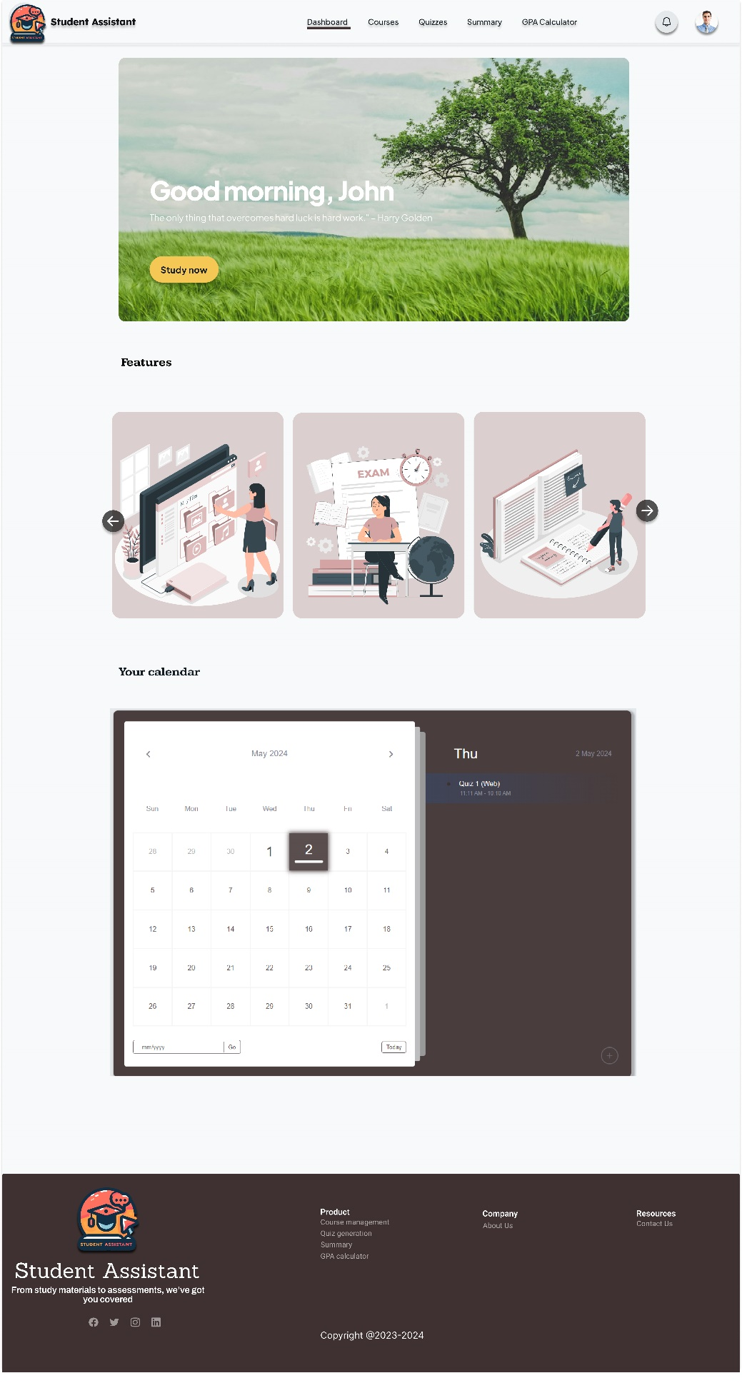

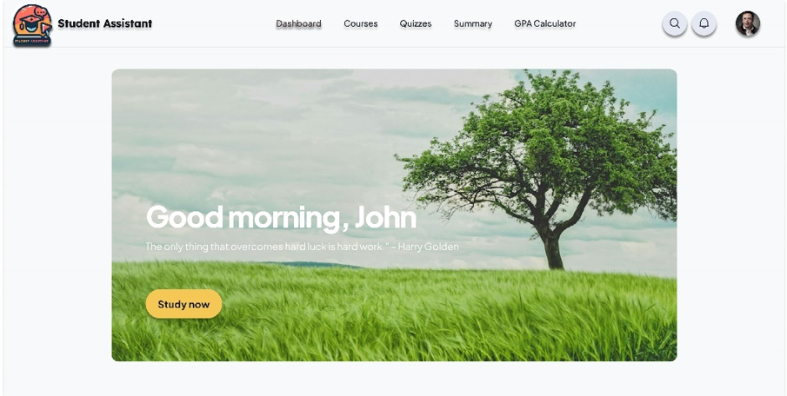

Welcome to the student dashboard! The first section greets you with a dynamic gallery that refreshes with each login, offering a fresh visual experience every time. Additionally, a dynamic quote accompanies this section, changing upon each login to provide inspiration or motivation.

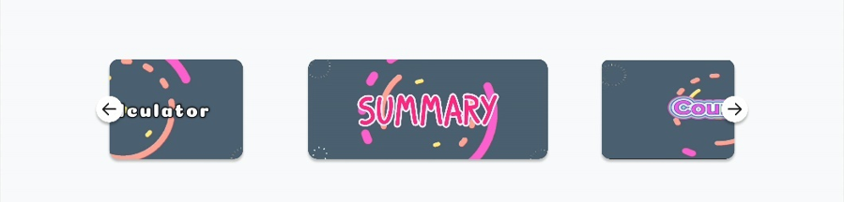

Moving on to the second section, it highlights the array of features available to the student. From summarization tools to engaging quizzes, accessible courses, and an overview of GPA, students have the flexibility to explore and utilize various functionalities tailored to their needs and preferences.

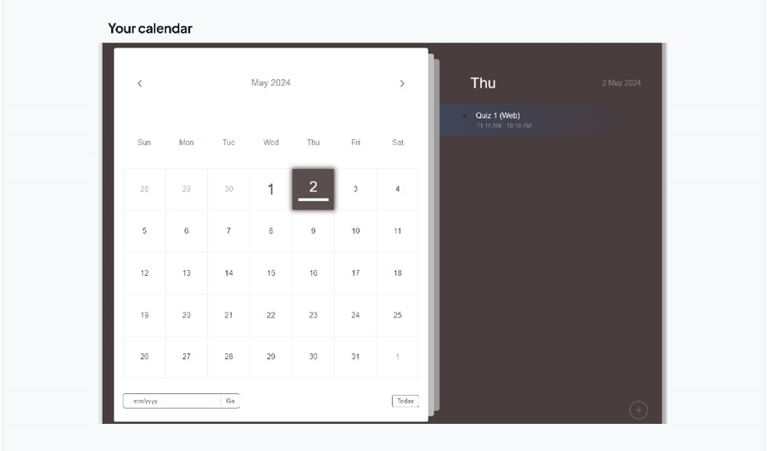

The final section of the dashboard is dedicated to organizing the student's schedule and deadlines. Here, they can effortlessly view today's deadlines and upcoming events, ensuring they stay on track with their tasks and commitments. Moreover, the calendar feature enables students to seamlessly manage their deadlines, offering the convenience of adding or deleting tasks as needed, thereby fostering effective time management and organization.

### Courses Page

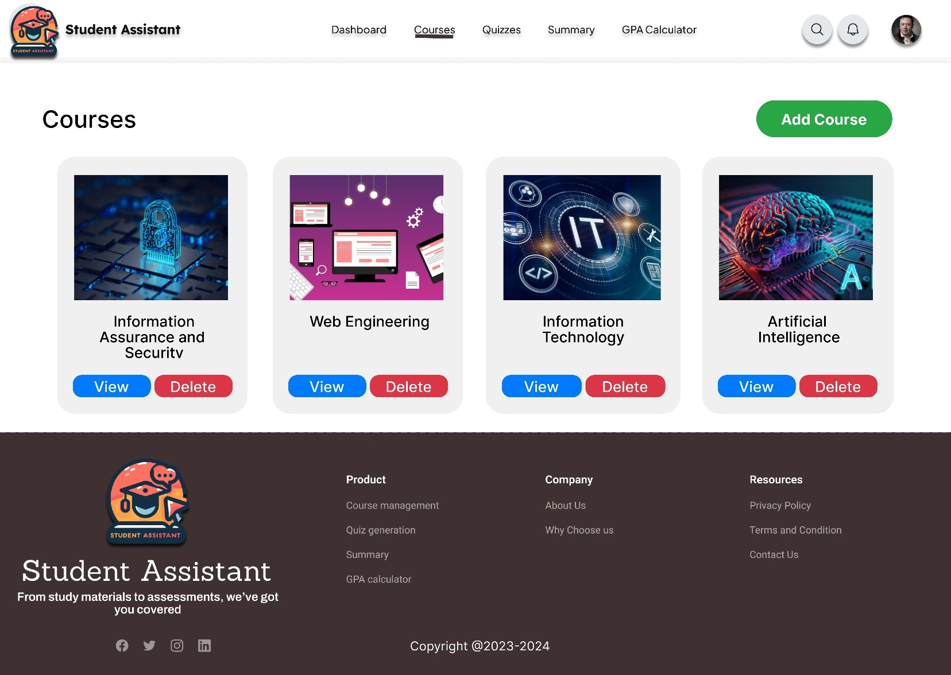

On this page, students have the ability to effortlessly manage their courses.

They can view, add, or delete courses with ease, while detailed information about each course is conveniently accessible on the following slide.

### A screenshot of a computer Description automatically generatedCourse Details

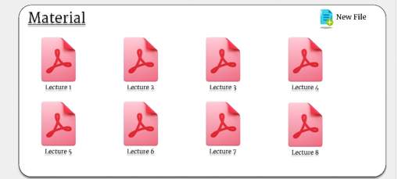

The initial section focuses on material files, allowing students to upload their own files or PDFs.

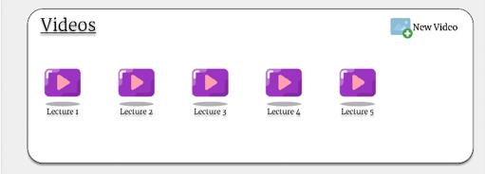

In the subsequent section, students can link course videos from various platforms such as YouTube, LinkedIn, or other educational platforms.

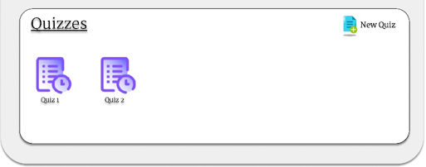

Lastly, the final section pertains to quizzes, where students can create quizzes using either uploaded files or linked content and from the summarized content too and they will be tagged to this course.

### A screenshot of a computer game Description automatically generatedQuiz Page

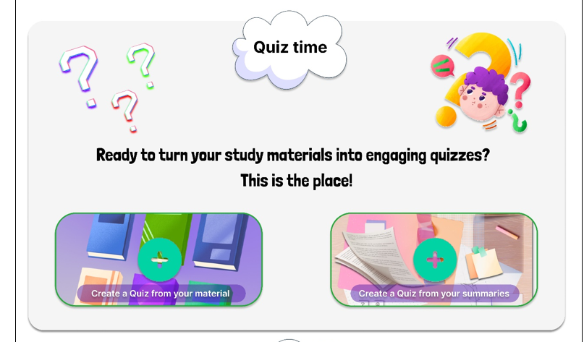

In this section, students have the capability to generate quizzes using either uploaded materials or summarized content.

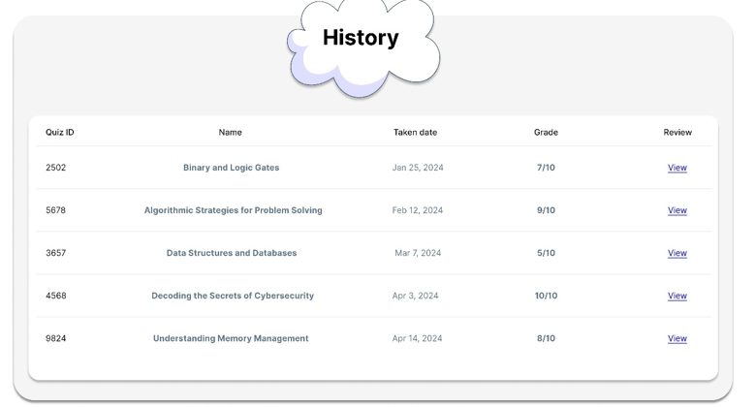

Here is the history of all quizzes, including those created either from the course page or from summarized content.

### Quiz_Questions

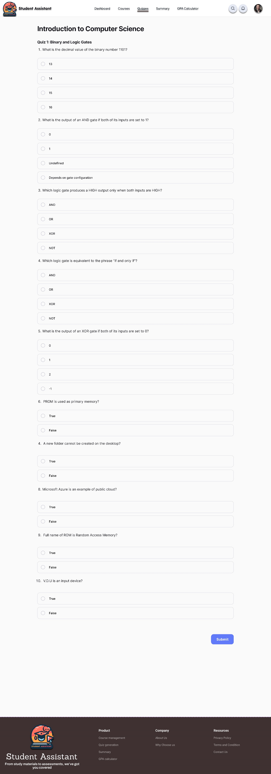

In this segment dedicated to quiz questions, it is thoughtfully divided into two distinctive parts, each contributing to a comprehensive assessment experience. The initial section encompasses eight multiple-choice questions (MCQs) and an additional set of two true/false inquiries. This deliberate structure ensures a balanced evaluation approach, encompassing both objective and binary response formats.

With a primary focus on fostering engagement and comprehension, each question within this segment is intricately crafted to align seamlessly with the respective topic under examination. This meticulous alignment ensures that the quiz questions not only evaluate the students' knowledge but also serve as effective tools for reinforcing key concepts and principles.

The incorporation of multiple-choice questions facilitates a nuanced exploration of the subject matter, offering students the opportunity to select from a range of response options. This format not only encourages critical thinking and decision-making but also enables educators to assess the depth of understanding exhibited by each student. Similarly, the inclusion of true/false questions provides a contrasting perspective, prompting students to discern the accuracy of statements in relation to the topic at hand. Such binary assessments not only gauge factual comprehension but also enhance students' ability to differentiate between accurate and erroneous information.

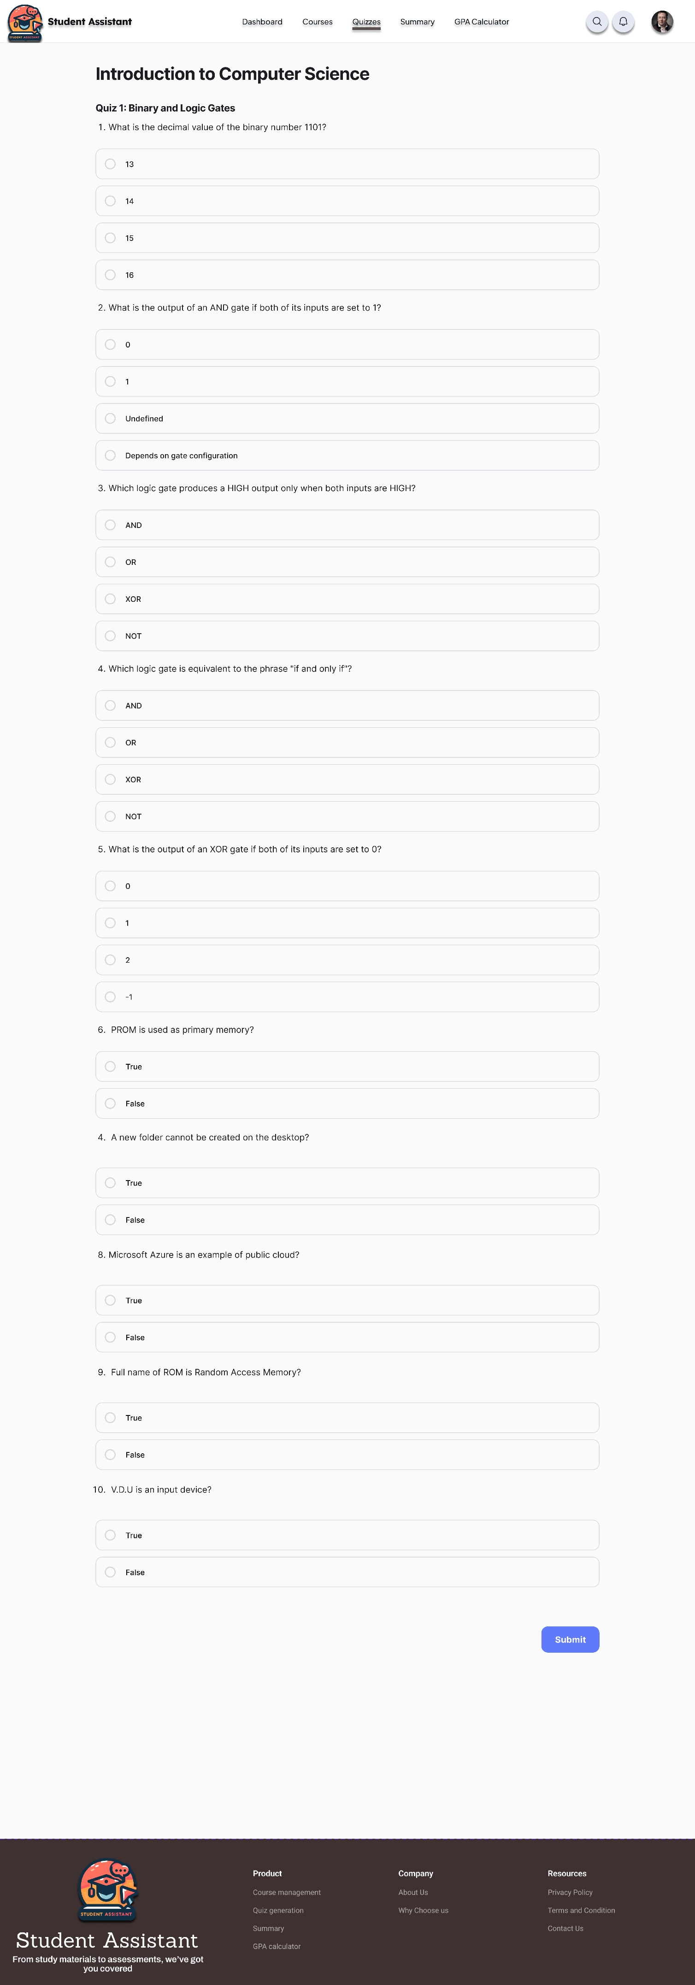

Moreover, the interactive nature of these quiz questions fosters an immersive learning environment, wherein students actively engage with the content and apply their knowledge to respond effectively. This active participation not only consolidates learning but also cultivates a sense of ownership and accountability for one's academic progress.

Furthermore, it's imperative to highlight that the assessment process doesn't culminate with the completion of the quiz questions. Instead, upon submission, students are provided with immediate feedback, facilitating continuous learning and improvement. Additionally, the quiz is graded at the end, enabling students to gauge their performance and identify areas for further review and refinement.

In essence, this section dedicated to quiz questions serves as a pivotal component of the overall learning experience, offering a dynamic platform for assessment, engagement, and knowledge reinforcement. By aligning questions with the topic, adopting diverse response formats, and providing timely feedback, educators can effectively leverage quizzes as valuable tools for promoting student learning and academic success.

### Student_Summary

Within this section, three distinct methods for summarization are available. The initial approach involves inputting a video link sourced from any learning platform. Subsequently, an AI system will process the content of the video and generate a summarized text based on its analysis.

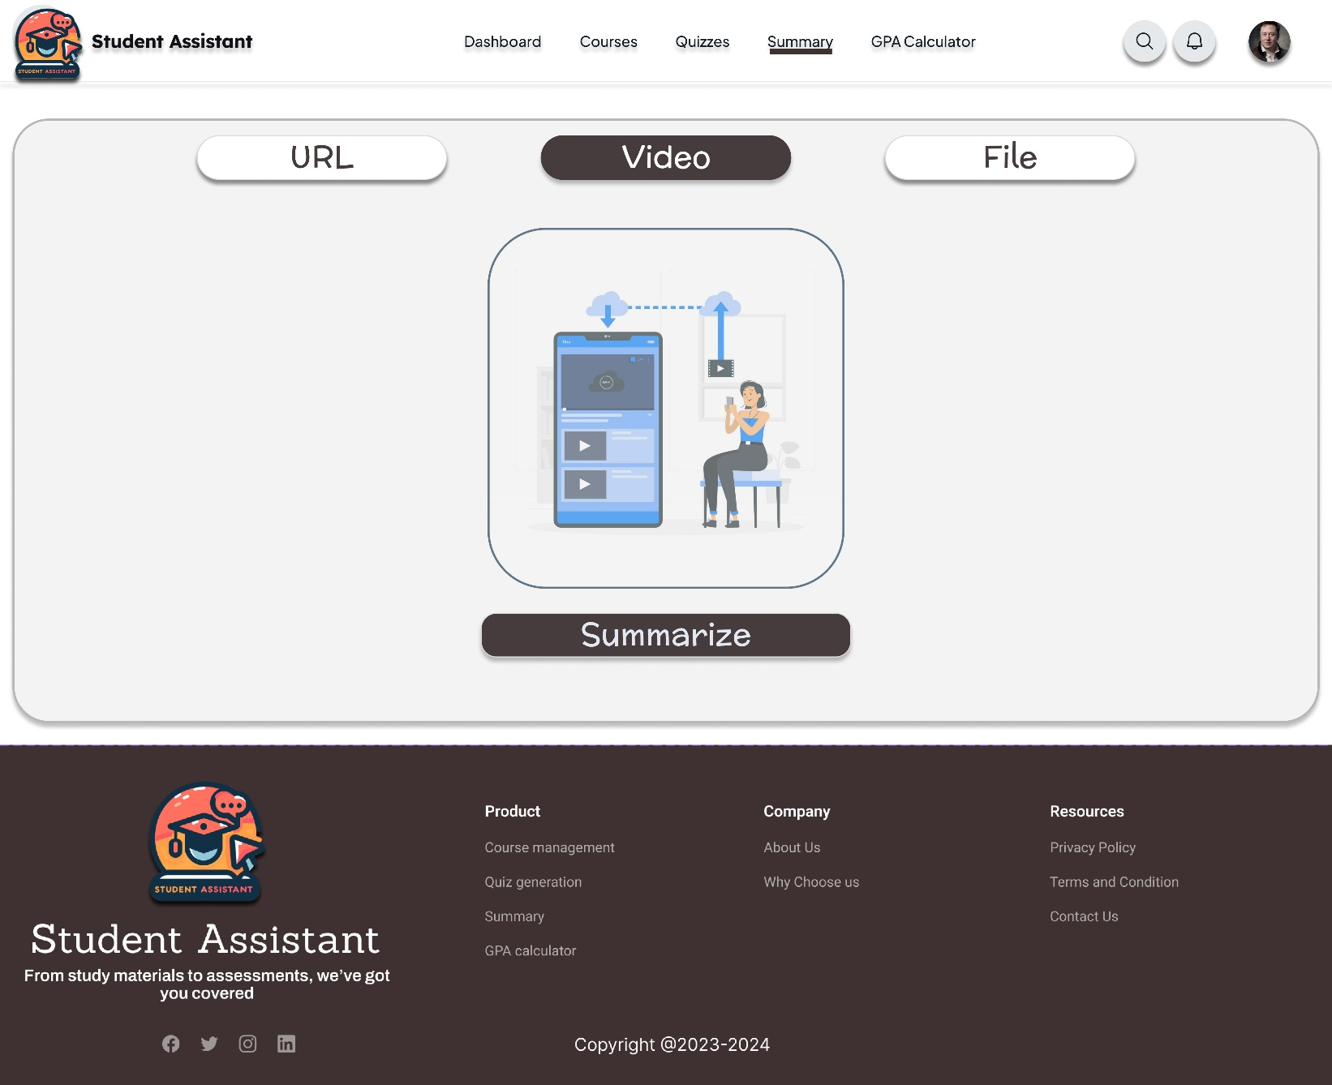The second method entails uploading a video directly from the user's local machine. Following this, the AI system will undergo the same summarization process on the uploaded video content.

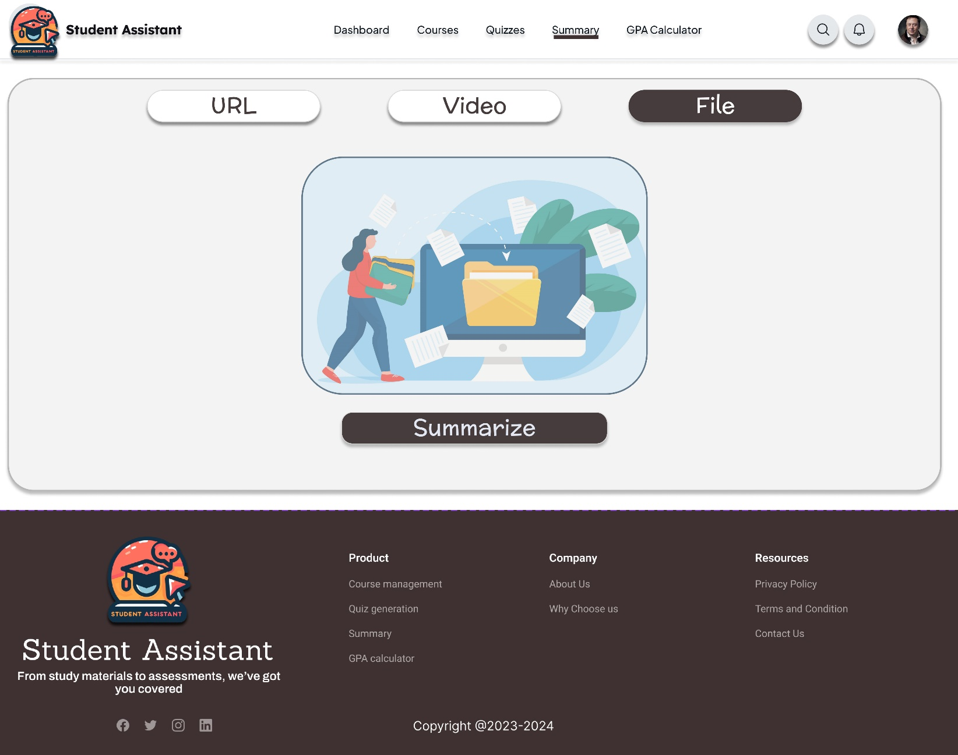

The final method involves uploading material in PDF format. Once uploaded, the AI system will proceed to summarize the content contained within the file.

### Student_GPA

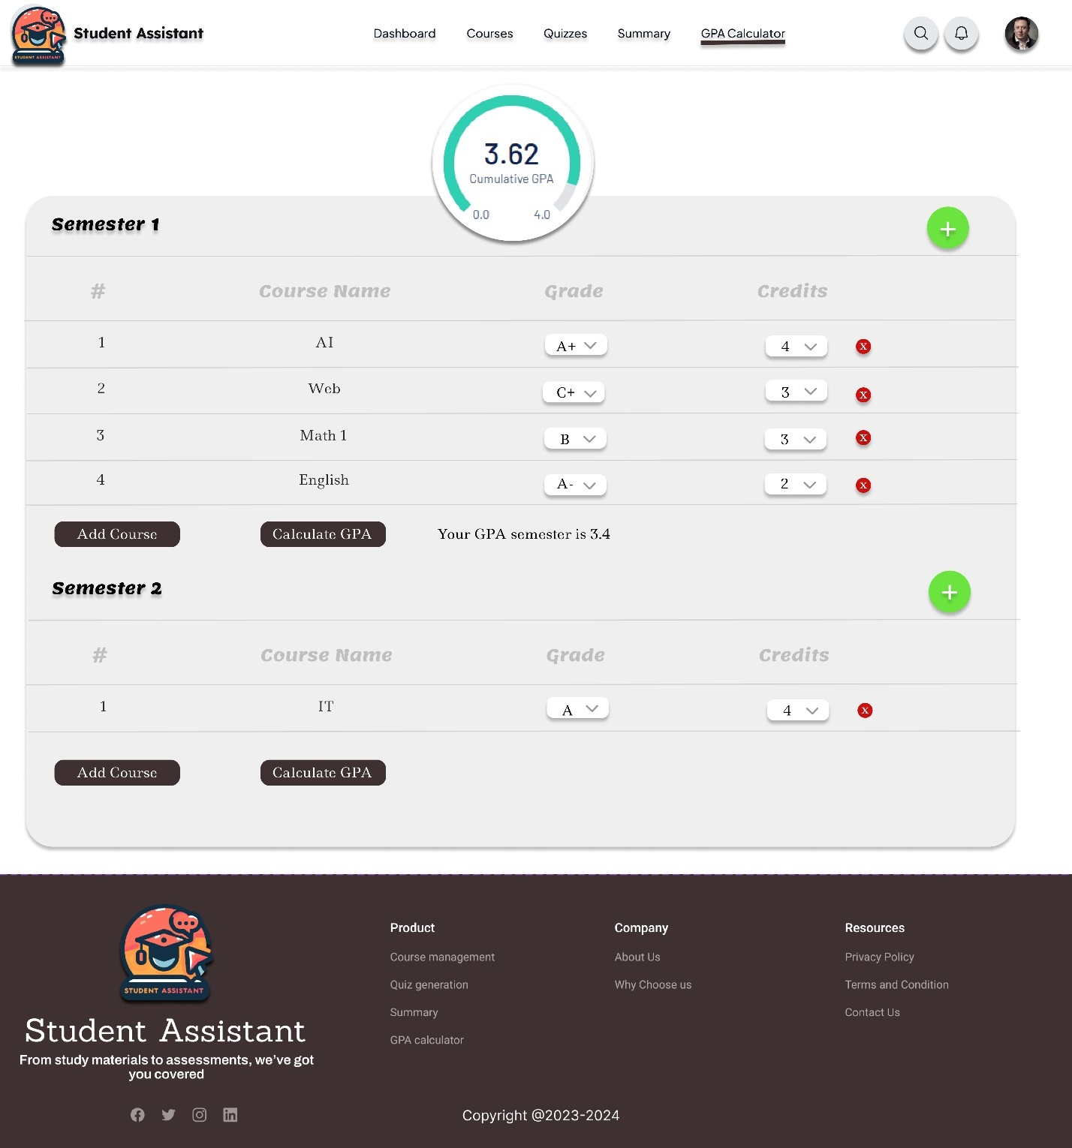Here is the student GPA page, where students can manage their academic performance. Within this page, students can add semesters, and within each semester, they can input their courses along with their corresponding grades and credit hours.

They have the option to calculate either the semester GPA individually or the overall cumulative GPA for all semesters.

### Student_Profile_Page

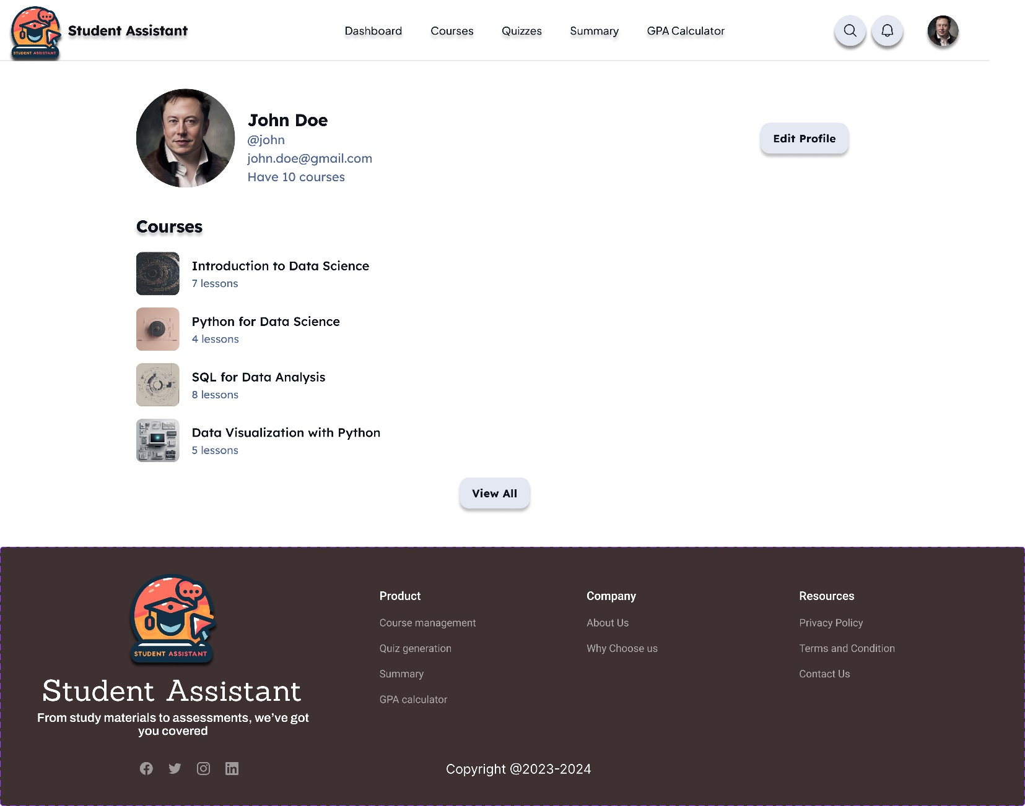

### Edit_Profile

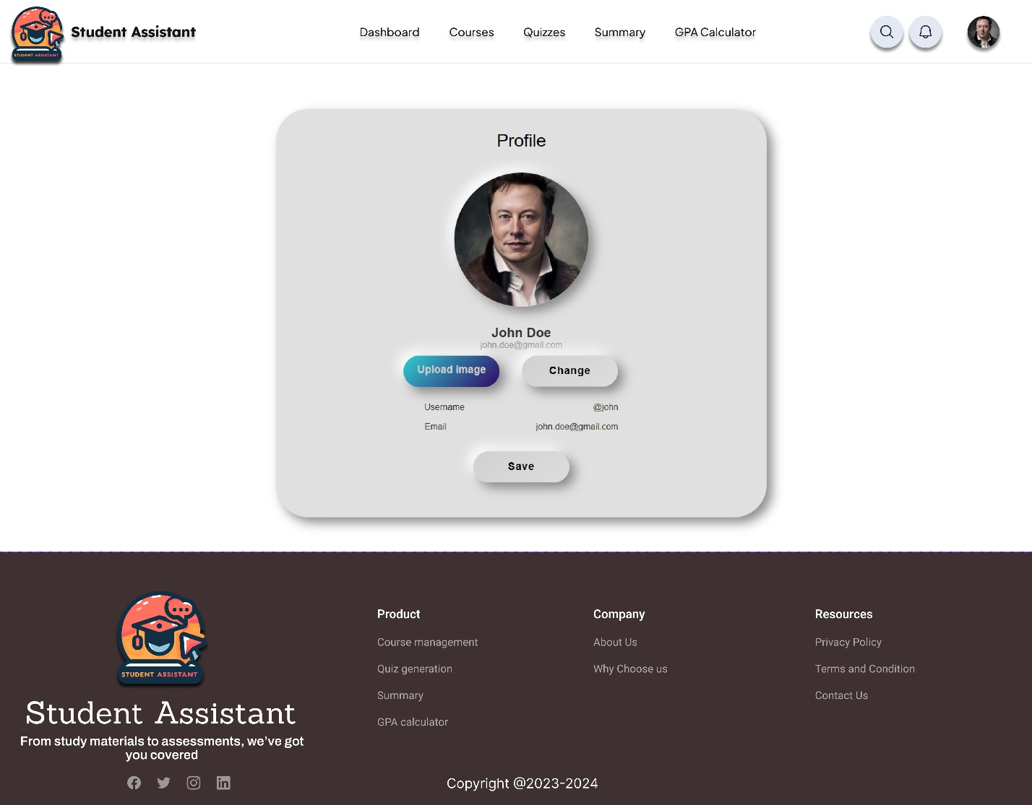

### Contact us

### About us

## Admin_Side

### Admin_Dashboard

### Student_Informations

### A screenshot of a social media feedback Description automatically generatedFeedback

**Chapter 11**

**Implementation**

* **Frameworks**
* **API Logic**

# Implementation

## System's Programming Languages

* Front-end side:
* HTML5
* CSS
* JAVASCRIPT
* Back-end side:
* PHP
* MySQL(DATABASE)
* Python

## Frameworks

Frameworks used within the system:

* Flask (web framework written in Python that empowers developers to build dynamic and secure web applications quickly and efficiently)
* Bootstrap (pre-built styles and components for responsive web design)

## A screen shot of a computer program Description automatically generatedAPI Logic

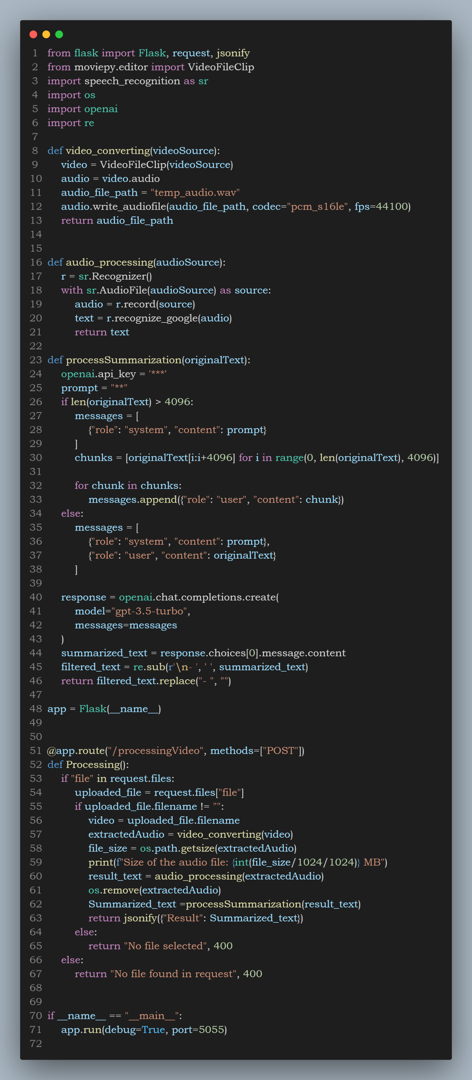

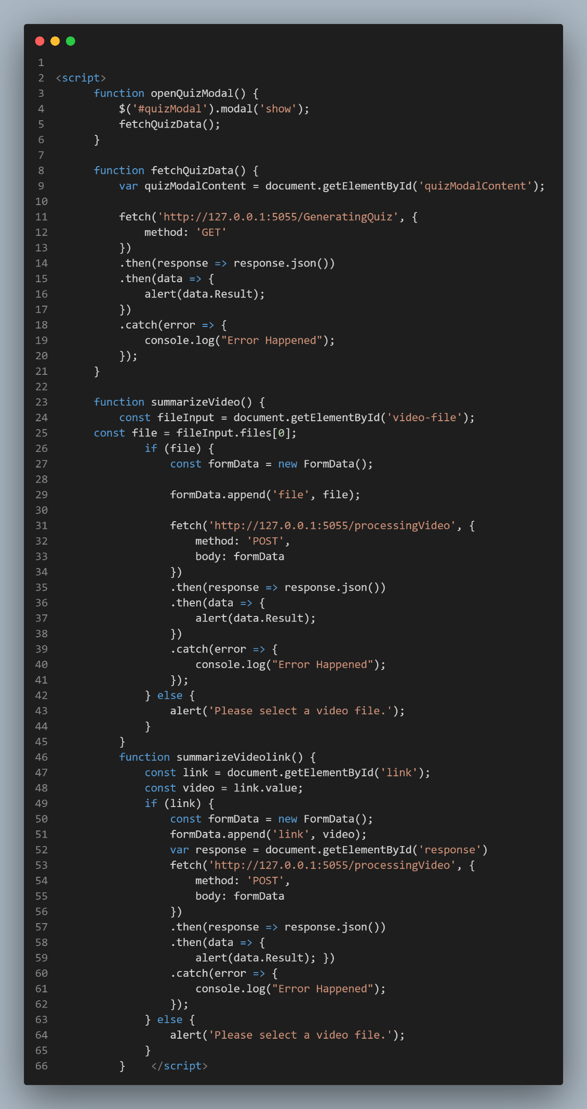

This page relies on several functions (detailed in the next figure) that work together to send requests to the back-end system and retrieve the necessary information.

If you notice there is a line of code that tries to communicates with the back-end.

e.g., line 11, 31, and 53.

That communication retrives the summary of the content requested through an “API”.

## A screen shot of a computer program Description automatically generatedSummarize API Response

## A screen shot of a computer program Description automatically generatedQuiz API Response

## A screen shot of a computer program Description automatically generatedFetches Quiz Questions

## A screen shot of a computer Description automatically generatedAPI Interaction and Authentication

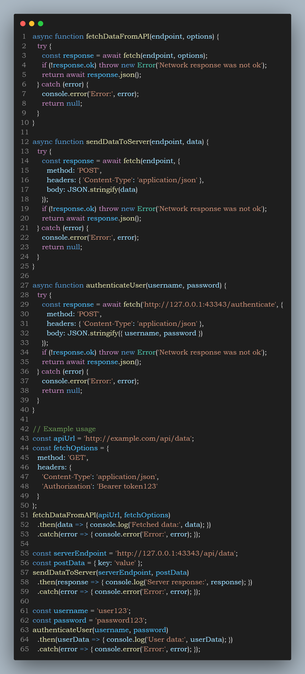

## A screen shot of a computer Description automatically generatedEdit profile Logic

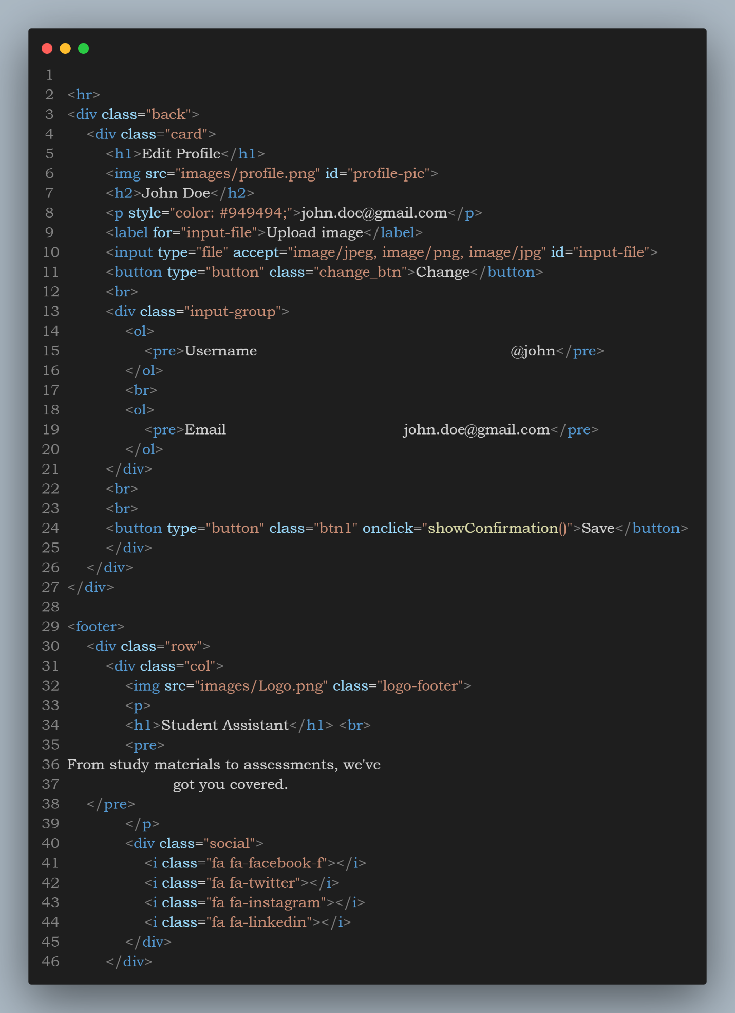

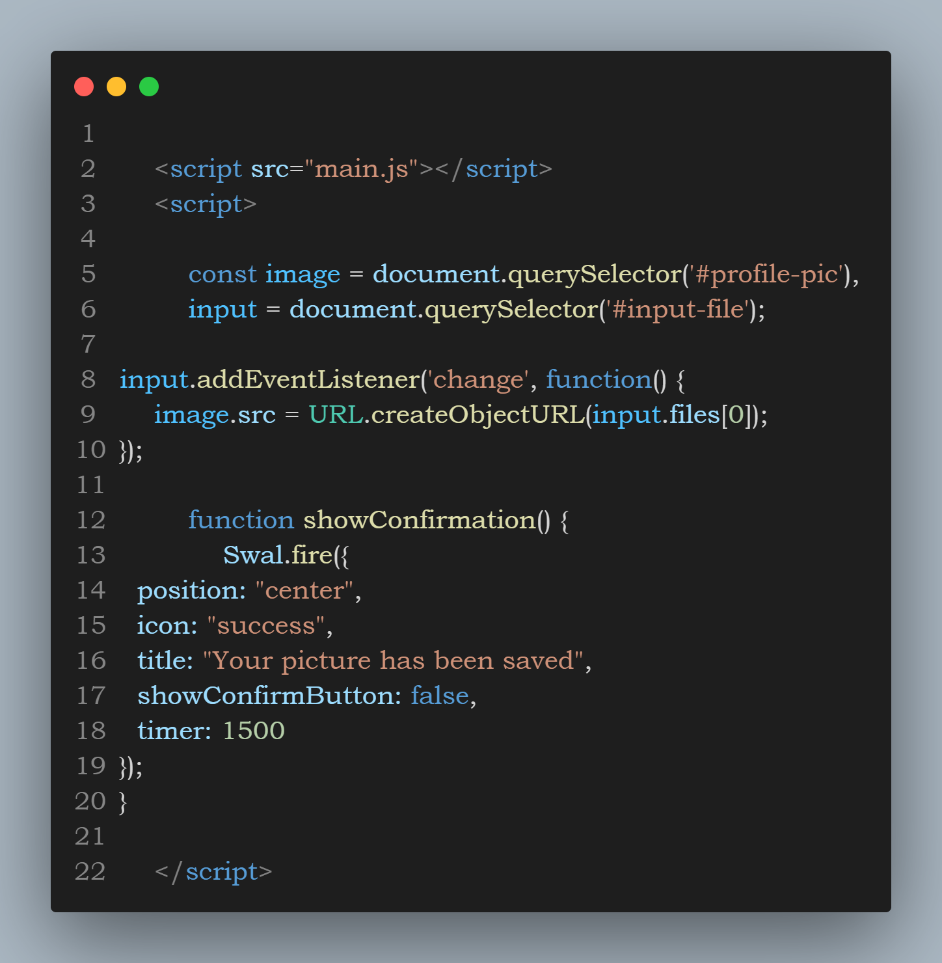

## A screen shot of a computer program Description automatically generatedSummary logic

## A screen shot of a computer program Description automatically generatedCalendar imp.

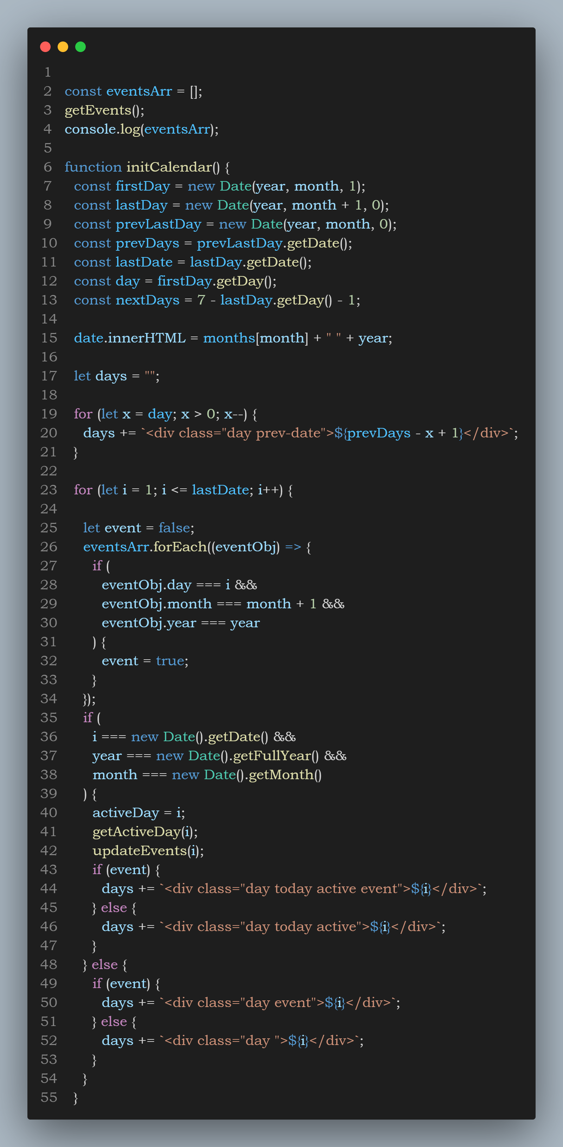

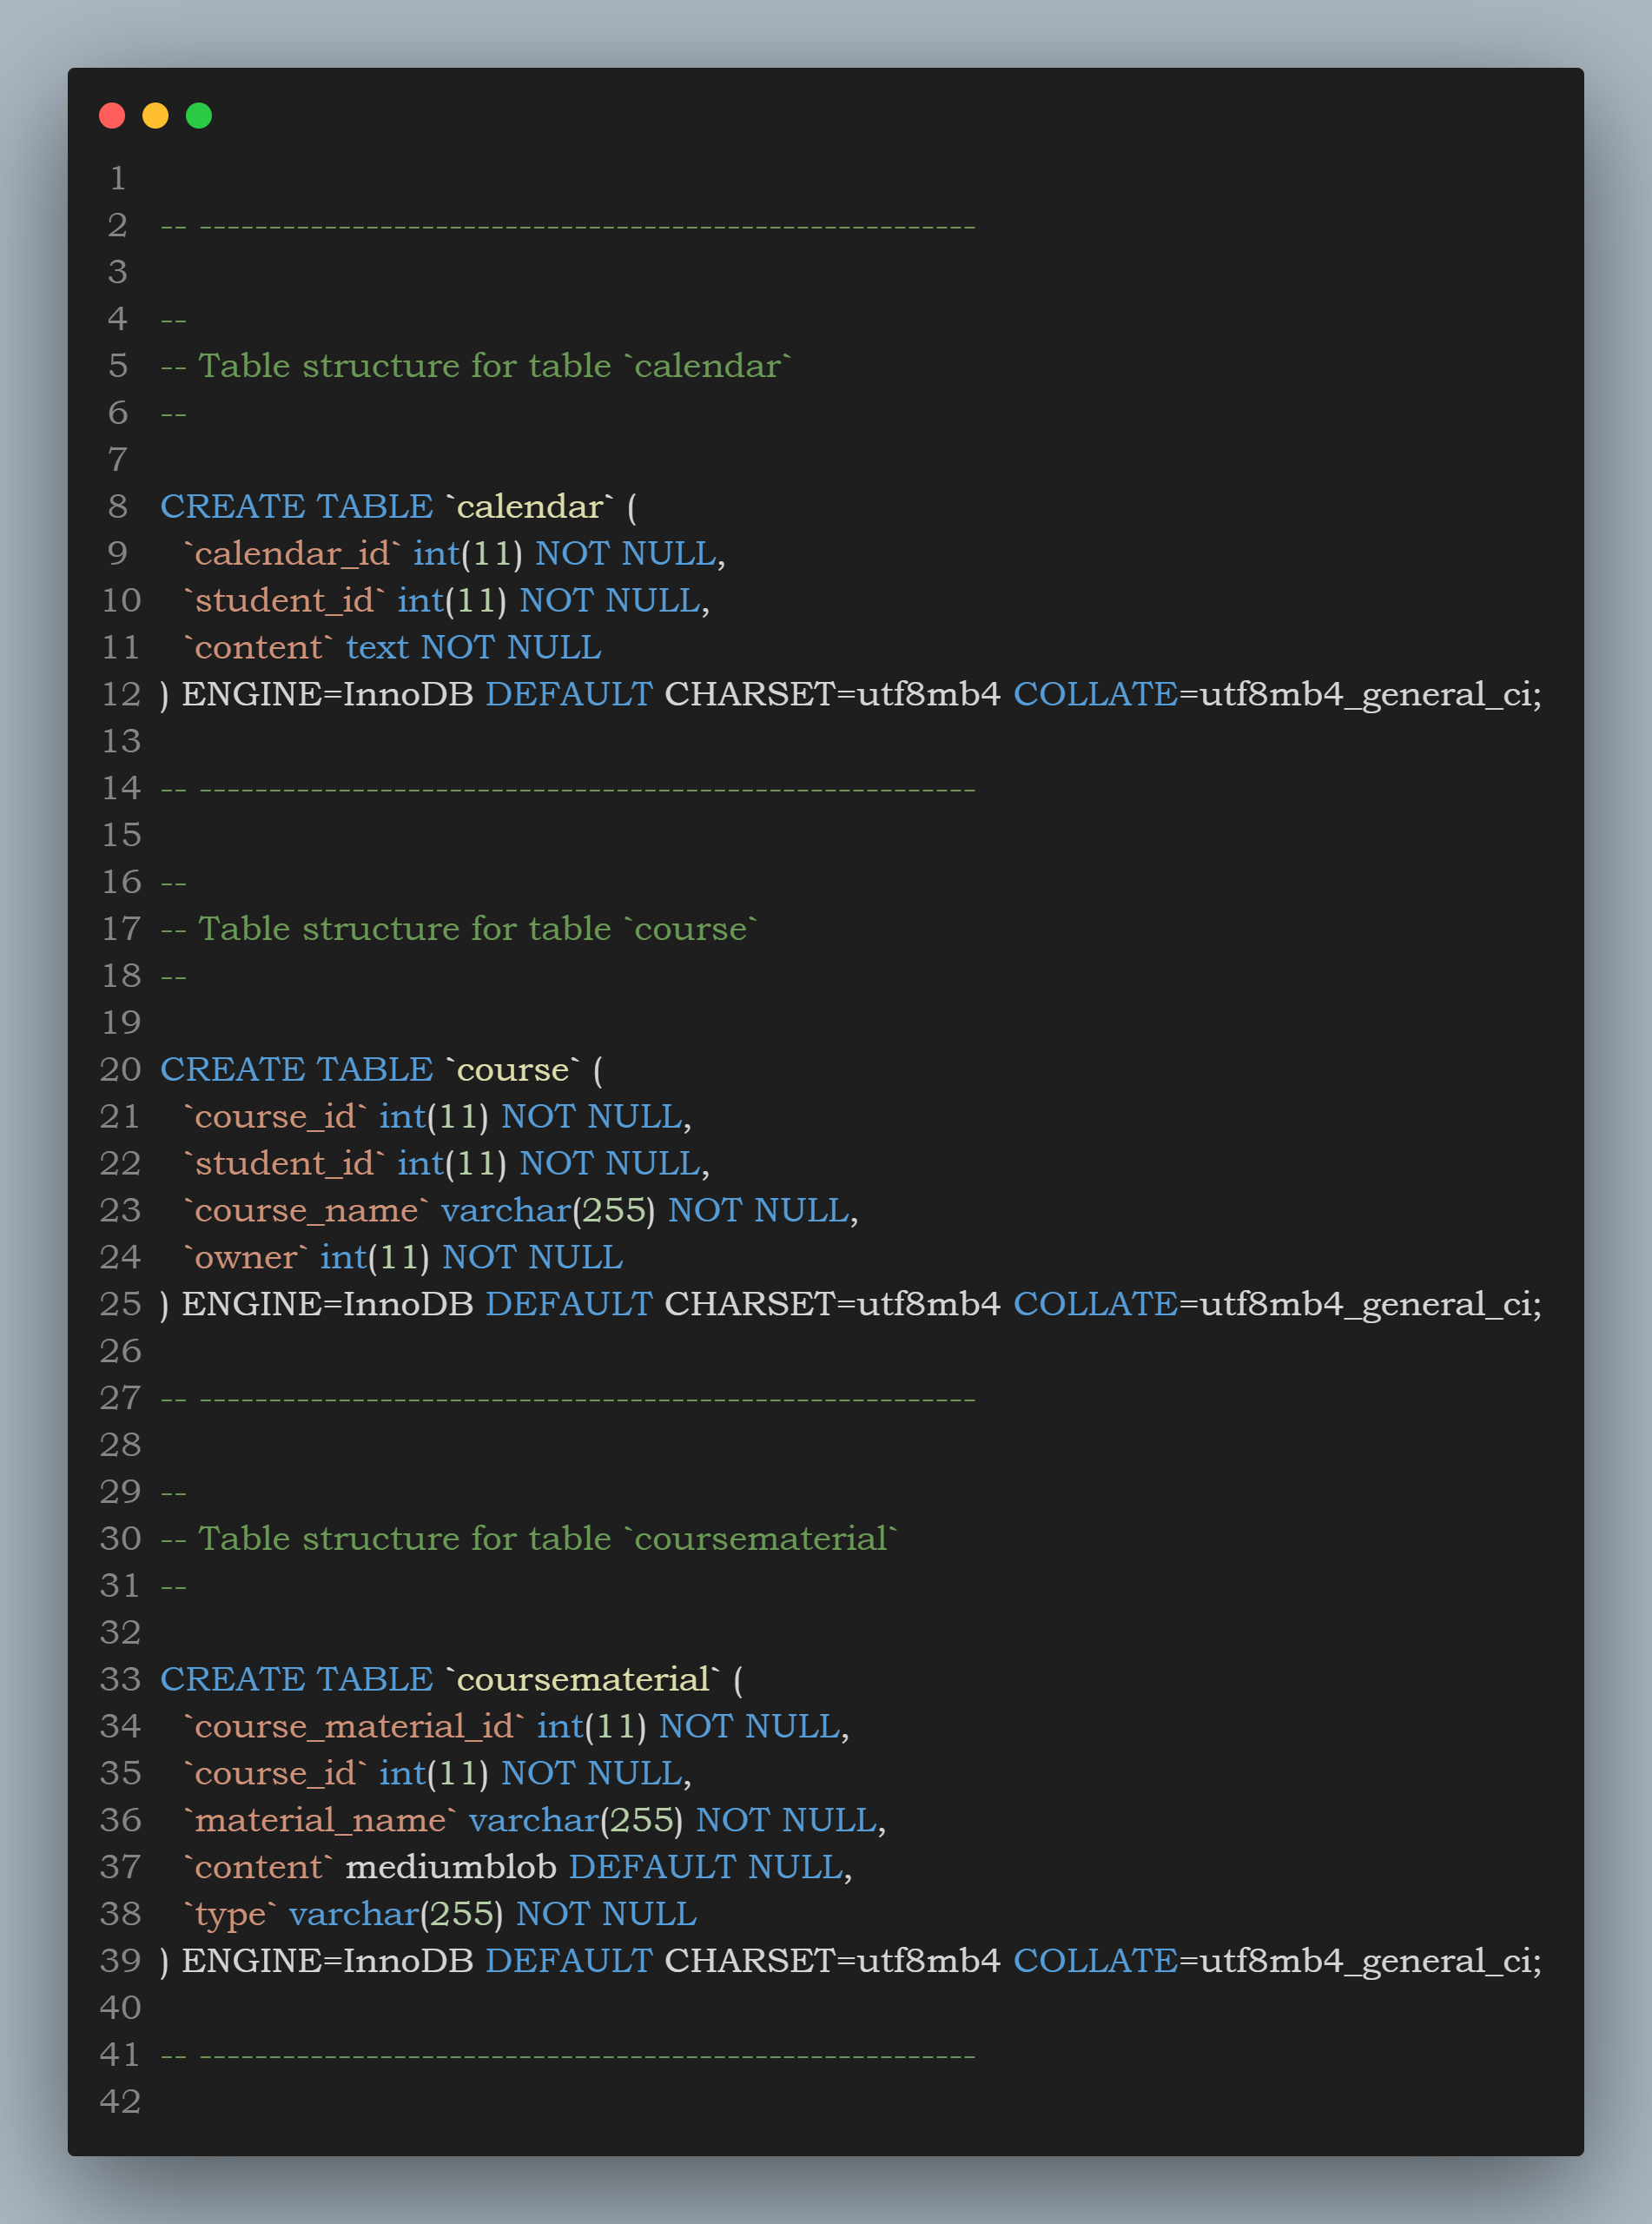

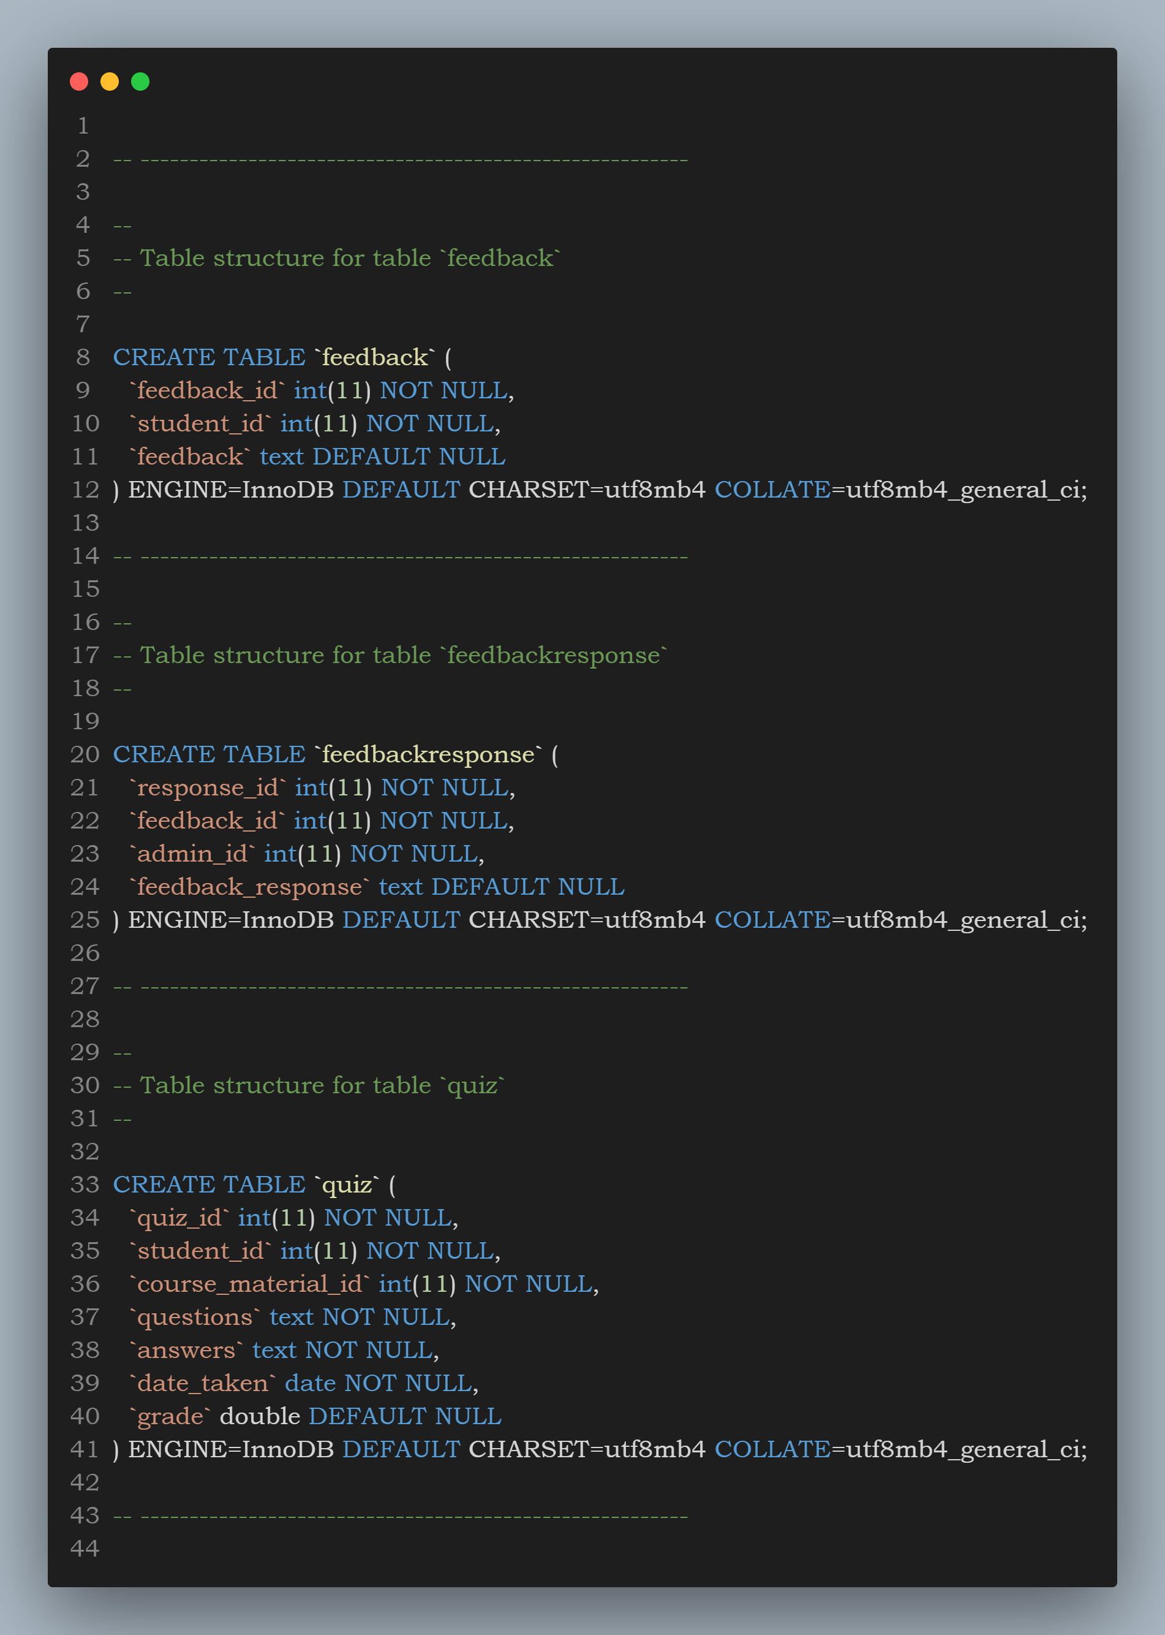

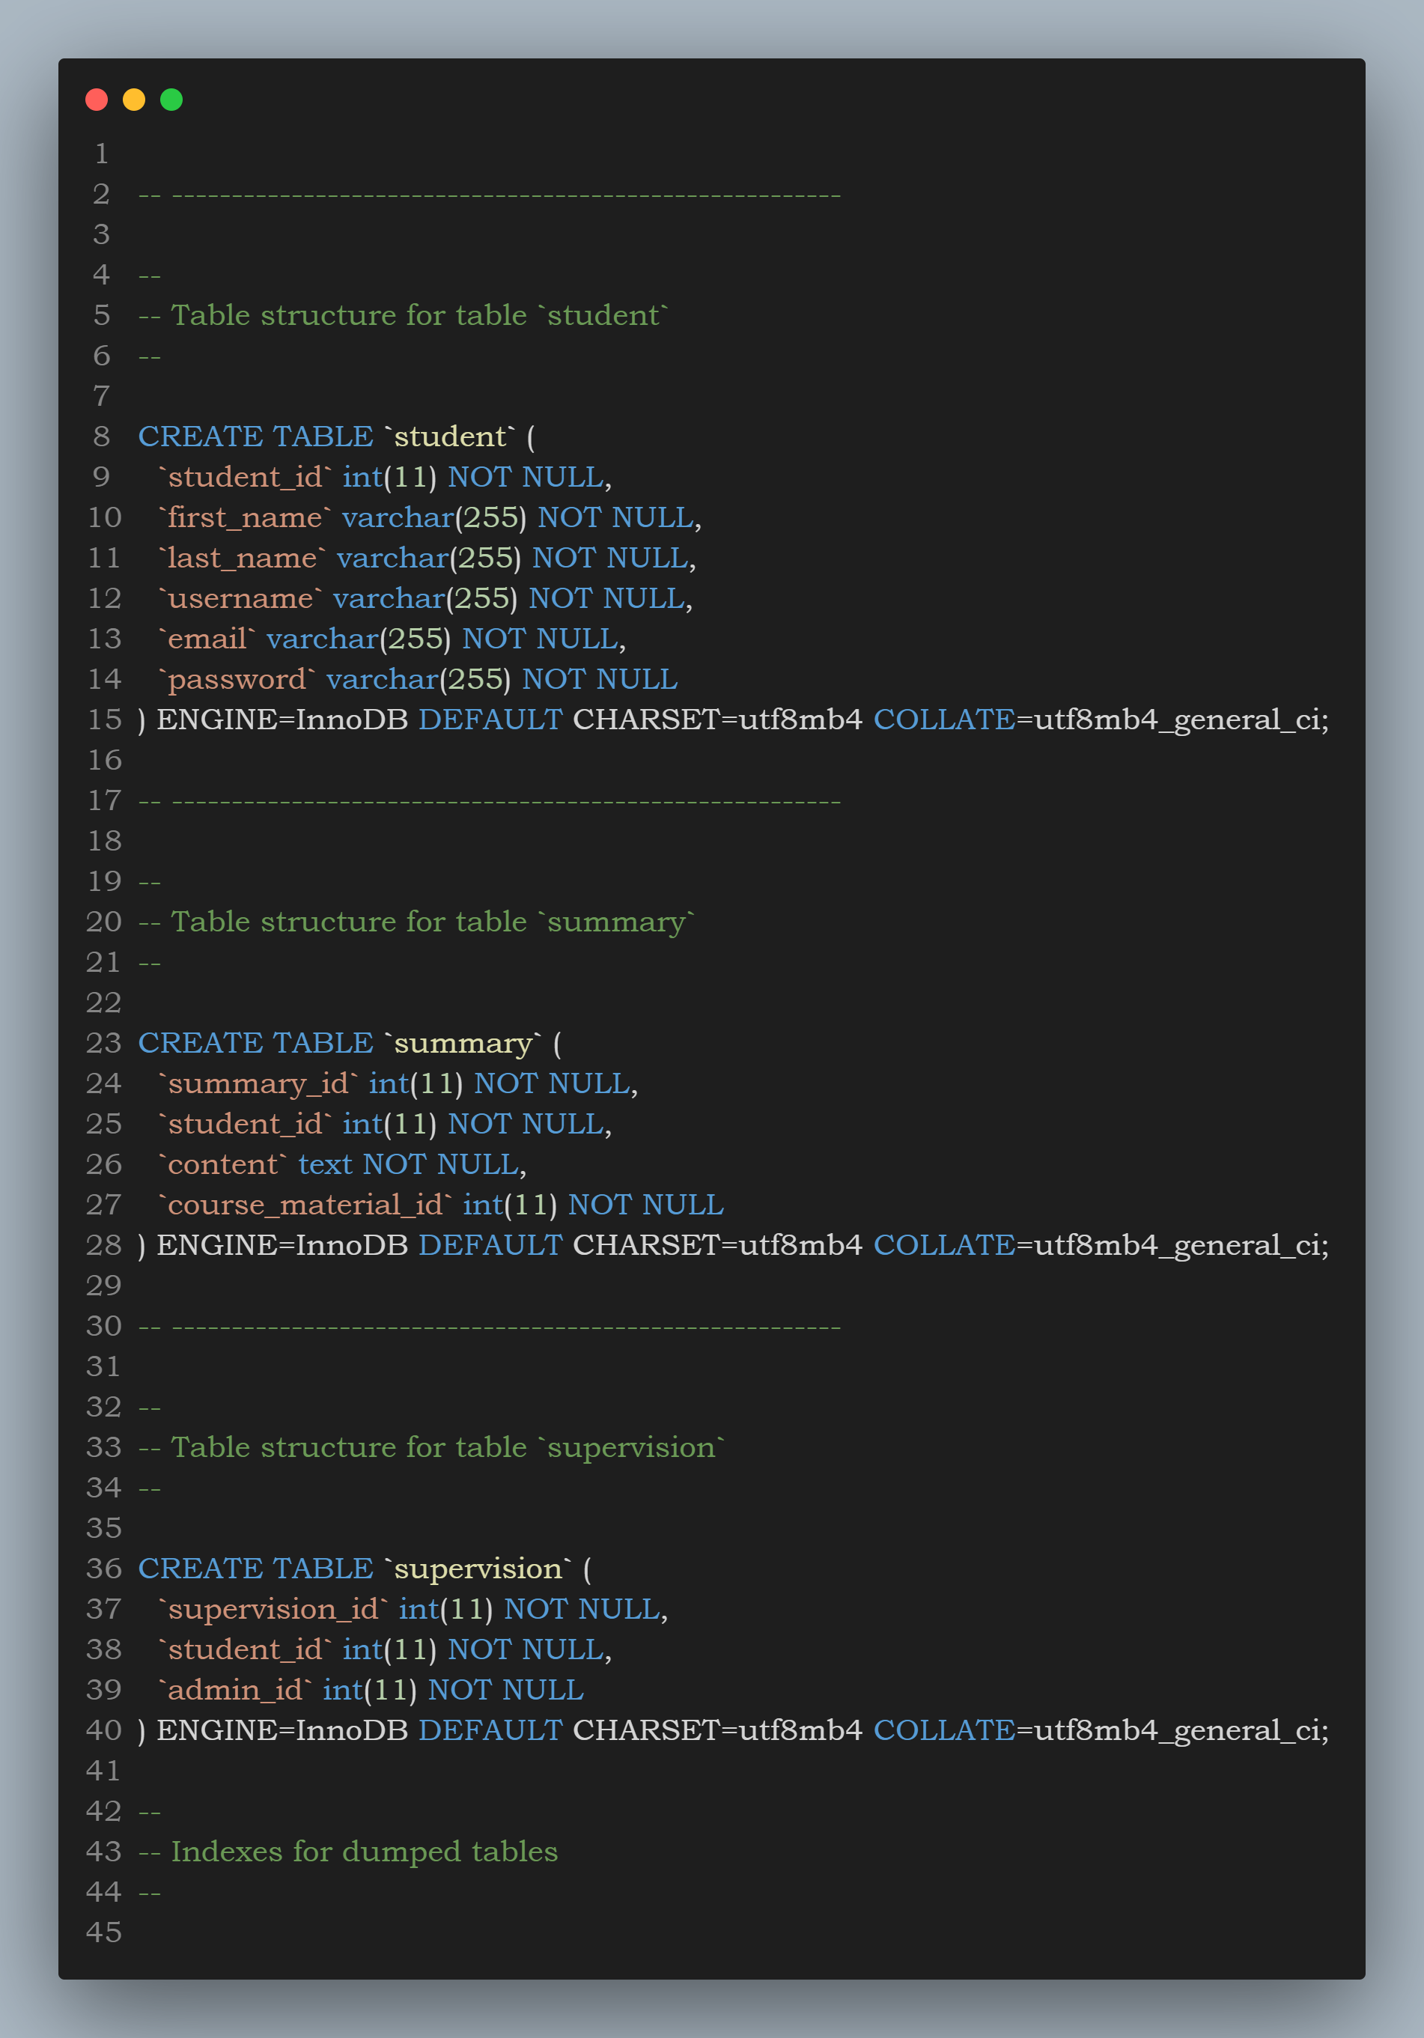

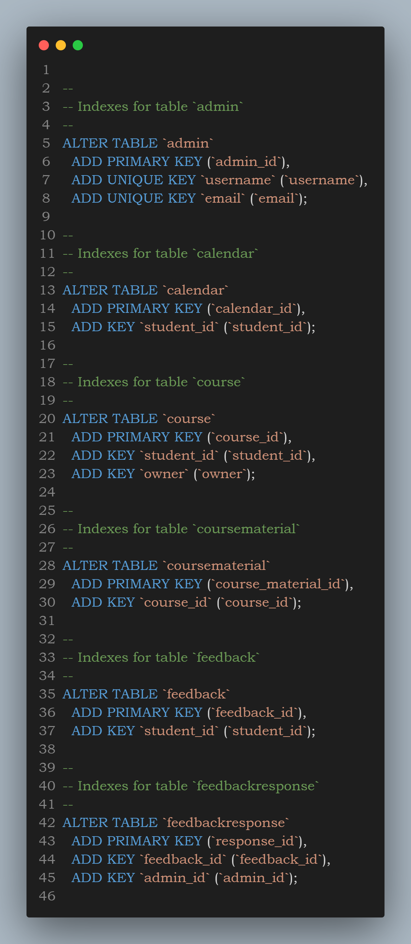

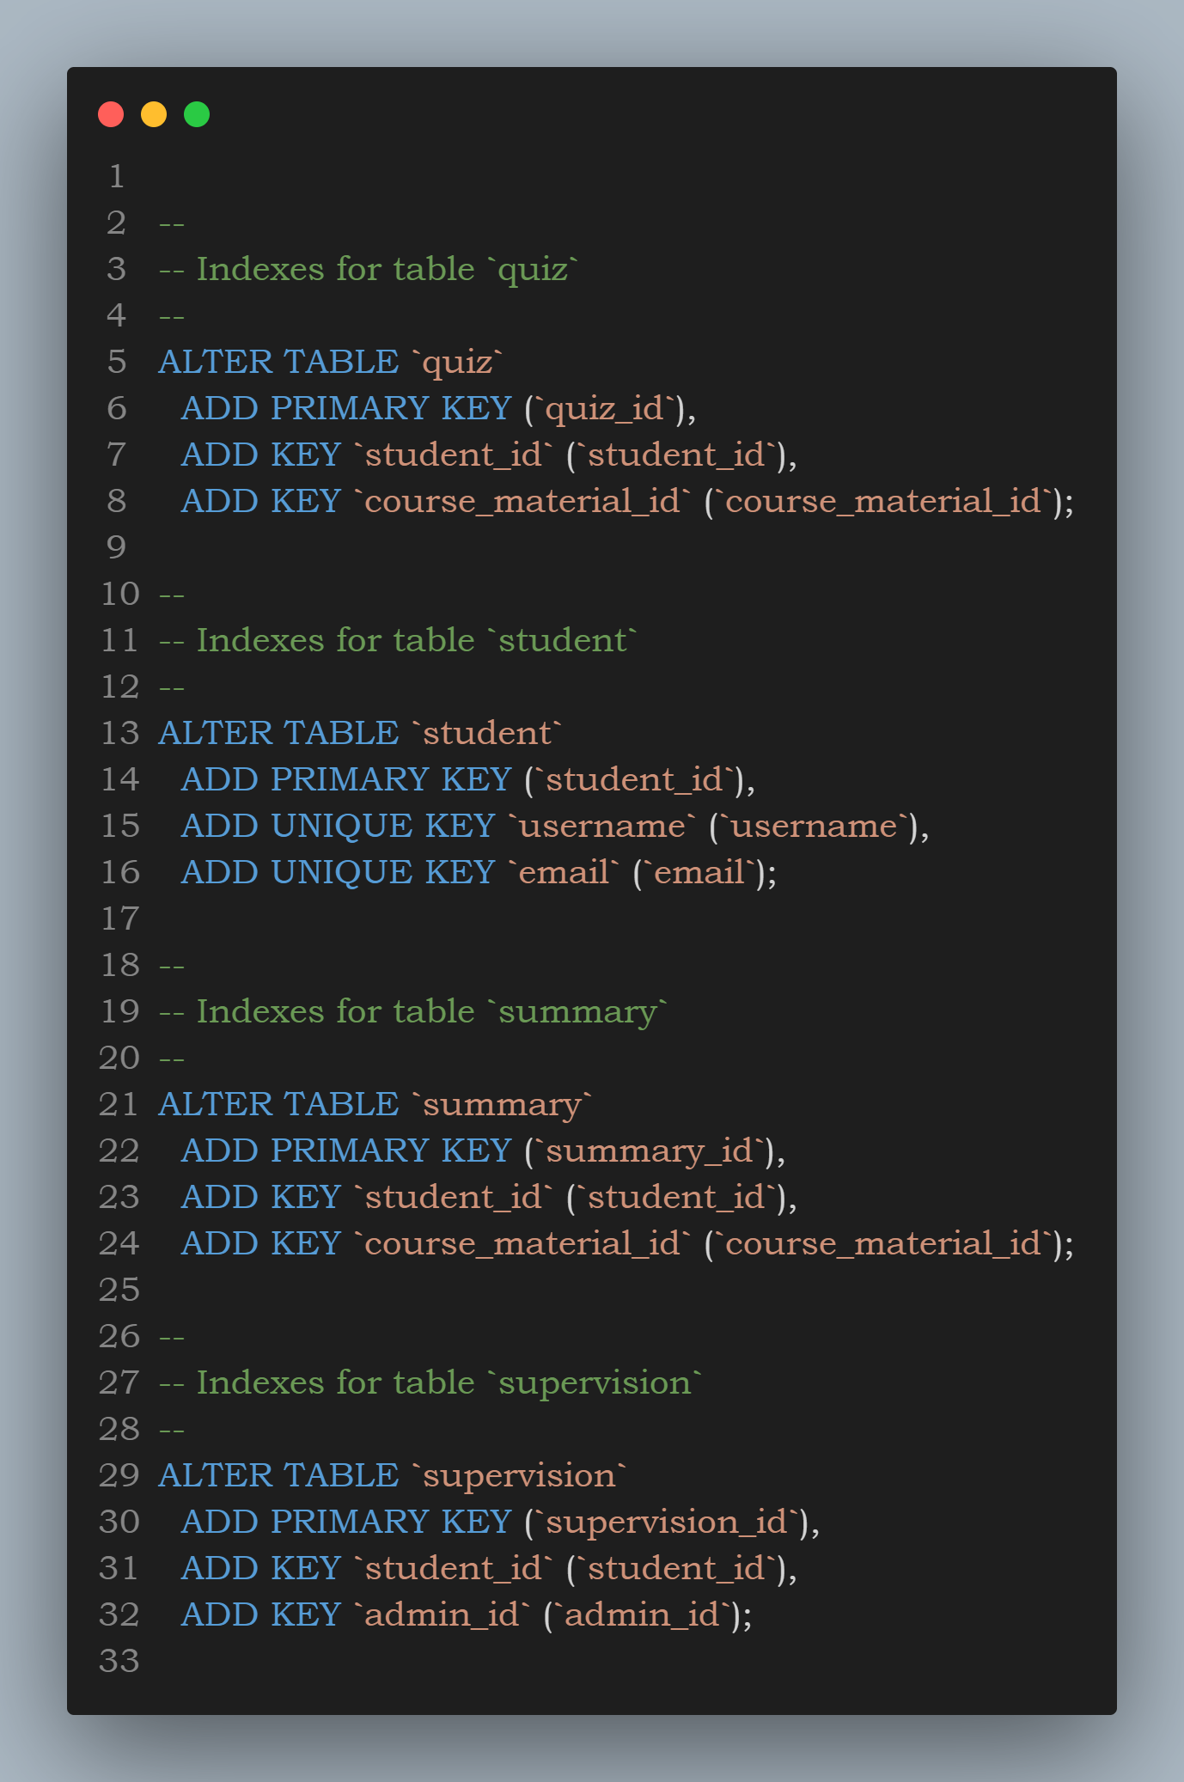

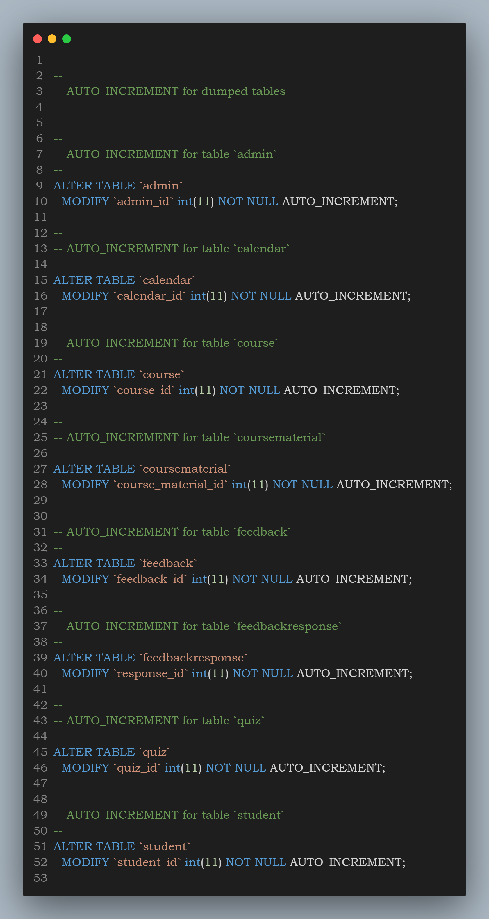

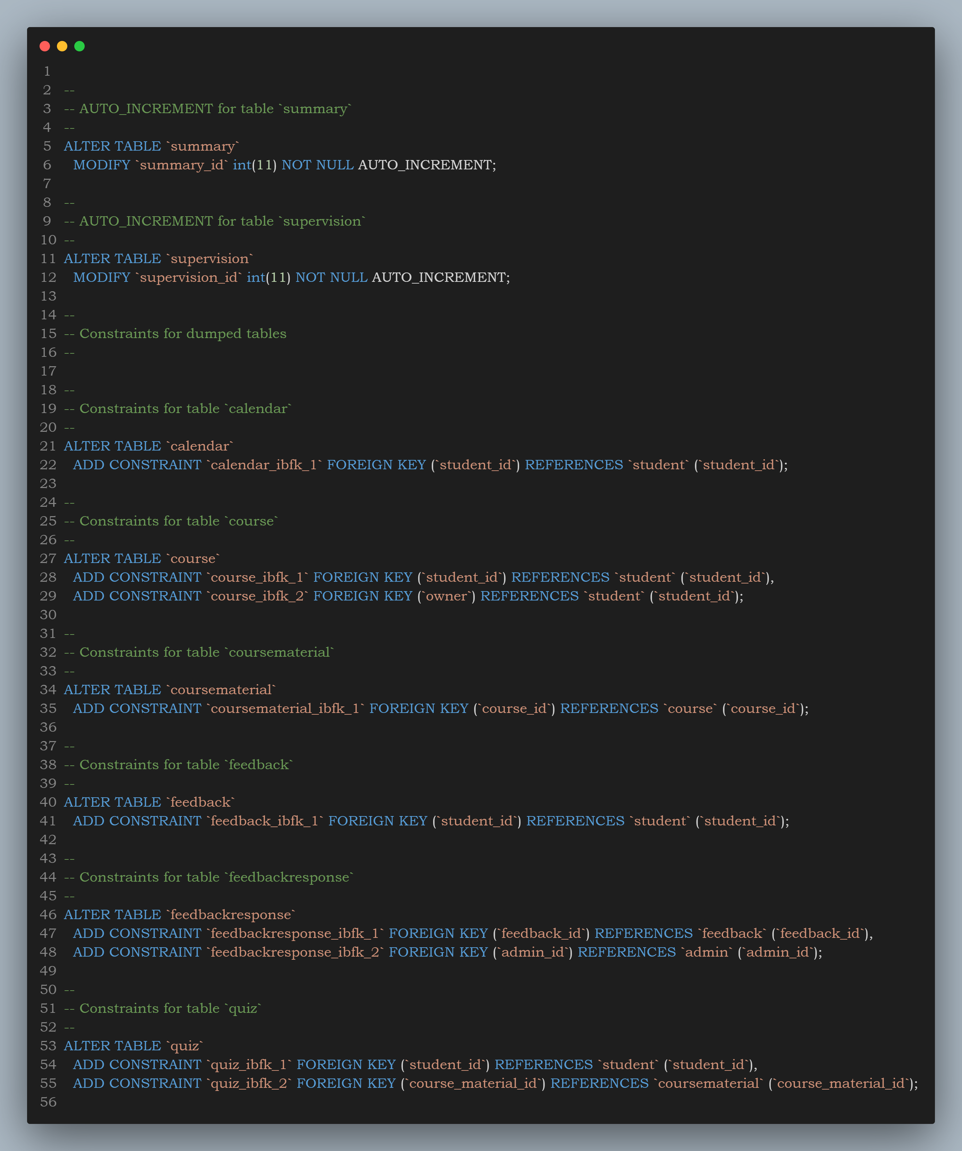

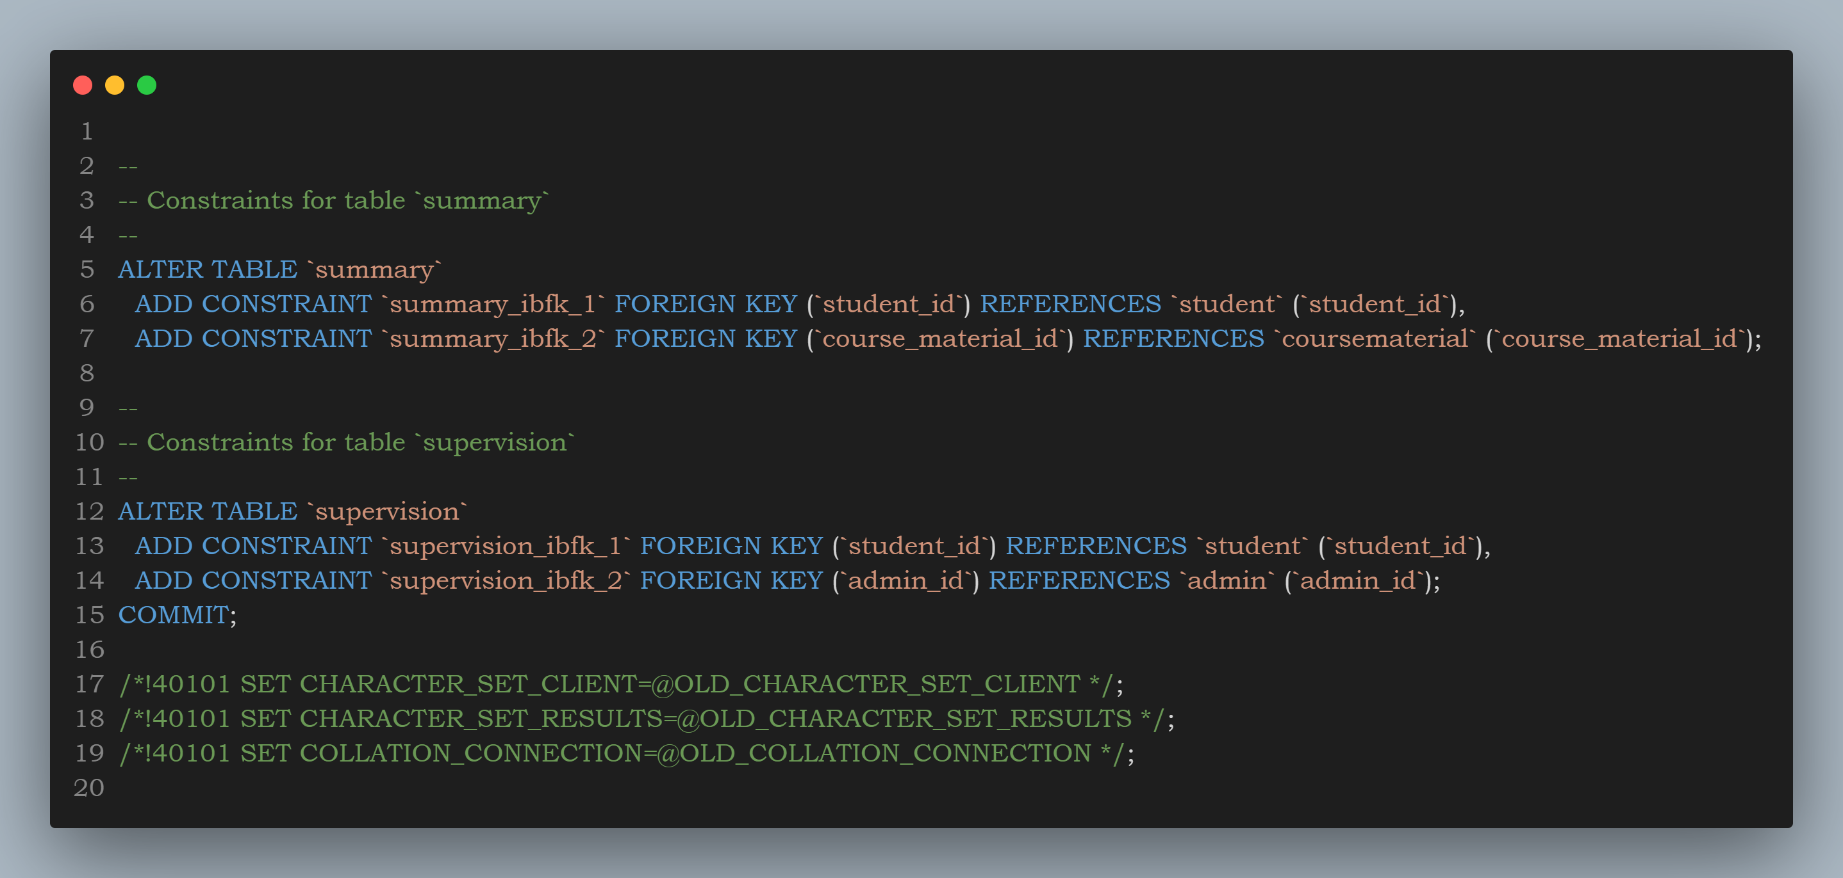

**Reference**

* **Reference URL**

**Chapter 12**

# Reference URL

https://www.linkedin.com/learning/programming-foundations-apis-and-web-services

https://www.youtube.com/watch?v=NWPYk417yE&pp=ygUEc3FsIA%3D%3D

https://www.w3schools.com/python/python_sets.asp

https://www.coursera.org/specializations/codio-generative-ai

https://www.w3schools.com/php/php_regex.asp

https://learning.edx.org/course/coursev1:HarvardX+CS50AI+1T2020/home

https://www.linkedin.com/learning/building-restful-apis-with-flask

https://www.coursera.org/learn/python-for-applied-data-science-ai

https://www.coursera.org/learn/sql-data-science

https://www.w3schools.com/php/php_casting.asp

https://www.coursera.org/professional-certificates/meta-back-end-developer

https://www.w3schools.com/python/python_dictionaries.asp

https://www.w3schools.com/php/php_forms.asp

https://www.udemy.com/course/complete-web-development-course/

https://www.w3schools.com/python/python_tuples.asp

https://www.coursera.org/professional-certificates/google-data-analytics

https://www.youtube.com/watch?v=GMppyAPbLYk&pp=ygUQYXBpIHB5dGhvbiBmbGFzaw%3D%3D

https://www.coursera.org/learn/sql-data-science

https://www.youtube.com/watch?v=HXV3zeQKqGY&pp=ygUEc3FsIA%3D%3D

https://www.udemy.com/course/canva-master-course-graphic-design-for-beginners/

https://www.youtube.com/watch?v=F7AKWzpYdY&list=PLMOobVGrchXN5tKYdyx-d2OwwgxJuqDVH

<https://www.w3schools.com/sql/sql_distinct.asp>

<https://www.w3schools.com/sql/sql_backup_db.asp>

https://www.w3schools.com/sql/sql_ref_sqlserver.asp

https://www.youtube.com/watch?v=qfEOE4vtxE&pp=ygUJYm9vdHN0cmFw

**Chapter 13**

**Final Overview**

* **Conclusion**

# Conclusion

The project aims to provide a seamless learning experience for students while offering comprehensive administrative tools for effective management.

For students, the platform facilitates effortless registration and account management, allowing them to sign up through various authentication methods, edit their accounts, and reset passwords when necessary. They can organize their learning materials by storing files or URLs, enabling easy access to course documents and bookmarking online videos.

Automatic summarization tools further enhance learning by providing concise summaries of videos and documents, fostering deeper understanding without the need for extensive searching. Personalized quizzes generated from summarized materials empower students to actively engage with the content and track their progress, while a dedicated calendar feature helps them stay organized and ahead of their academic schedule.

On the administrative side, the platform offers secure dashboard access for overseeing student data and system functions. Admins can view detailed student profiles, manage accounts, and analyze feedback to gain valuable insights into the student experience.

Responsive communication tools allow admins to address concerns directly, fostering an open channel of communication. Additionally, access to student performance statistics enables informed decision-making to optimize learning experiences and ensure the platform's smooth operation.

Overall, this project strives to create a holistic learning environment where students can focus on understanding and retention, supported by robust administrative functionalities designed to enhance their learning journey.

**THANK**

**YOU**